User Manual
Occupational Health Certificate
Public Health Department

Contents:

- Introduction: 3
- New OHC process flow: 5
- Create a New Occupational Health Certificate Request 9
- 1. Request Initial Submission 9
- 2. Request fee Payment 21
- 3. Medical Appointment Download 27
- 4. Medical Results Upload 30
- Create an Occupational Health Certificate Request from Draft 35
- Customer Action 38

Introduction:

The Public Health Department (PHD) of Ras Al Khaimah has published various online service to save the customers time and efforts, and to enable them to submit any request anytime from anywhere.

The customer (individuals /establishments) should have a registered account on the Public Health Department to be able to use the online services.

This service allows the establishments’ representatives to apply for the Occupational health certificate for the establishment’s workers (already registered workers) whether it is for new certificate, renew a certificate before or after expiry, or cancel certificate, by providing the required document and pay the fees.

This guide shows establishments’ representatives how to access the Occupational Health Certificate service. It also guides them on how to create, send, pay fees and track the request electronically.
Representatives will be able to log in to the service, submit requests, pay the fees, download medical appointment, upload medical result, track requests, modify requests (if necessary), re-submit the requests after applying the modifications electronically, and finally receive the certificate electronically.

Important Notes:
- To be able to apply for online services, the customer must apply on the Business Partner Establishment Update Information service, register his establishment and update his information in the system.
- The registration process is carried out electronically on the Ras Al Khaimah government link by following the steps below until reaching the services of Ras Al Khaimah Municipality →Public Health Department → Public Health Department Online Services, by submitting the following documents to register/update the establishment:
  - Copy of the License
  - Lease Contract/ Title Deed
  - Filled Establishment update information form for (Owner / manager / Representative contacts, EID number)
  - Letter of Authorization from the Company (if registering a company representative) with the ID/ Passport Number, full name and representative’s relation to the Company
N.B. In case Manager / owner is not mentioned in license
- The Customer must also register a company representative (an individual) by providing the following documents:
- Create an Internet user (Electronic Company Representative) and RAK Government portal account by:
    - Registering in RAK Government portal.
    - A valid Emirates ID Card is needed for the request
- Provide a letter of authorization from the Company including the company representative’s name, ID/Passport number and contact information
- Provide the representative’s ID/Passport number
- The Customer must also register a worker through worker registration service as prerequisite service.

New OHC process flow:

Login and access to the Register Occupational Health Certificate Service

- Navigate to the RAK Government portal on https://www.rak.ae/wps/portal
- To access the Occupational Health Certificate service, click on the “Service Guide” then click on “Government”

- Next, select “RAK Municipality”

- Next, select “Public Health Department”

- Next, click on the Issue/Renew/Cancel Occupational Health Certificate

- The service screen displays the service definition, procedure, conditions, fee, time, and the required documents.

- To use the service, click on the “Start Service” button.

Create a New Occupational Health Certificate Request

Request Initial Submission

- After you access the Occupational Health Certificate service and click on the “Start Service” button, the login page will appear as follow:

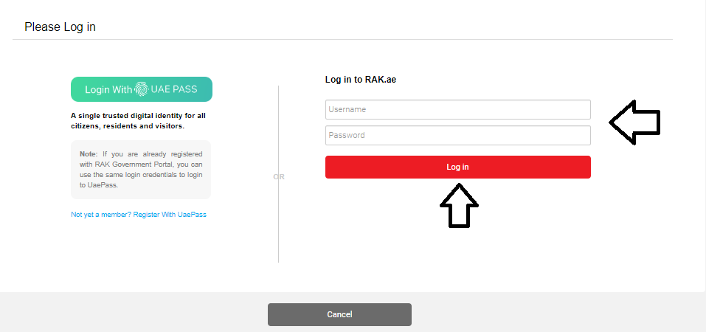

- Enter your RAK Government Portal username and password which you have previously created, then press on the “Log in” button.

- The Company Information form will be displayed enabling you to select the required establishment for whose workers you want to issue the OHC:
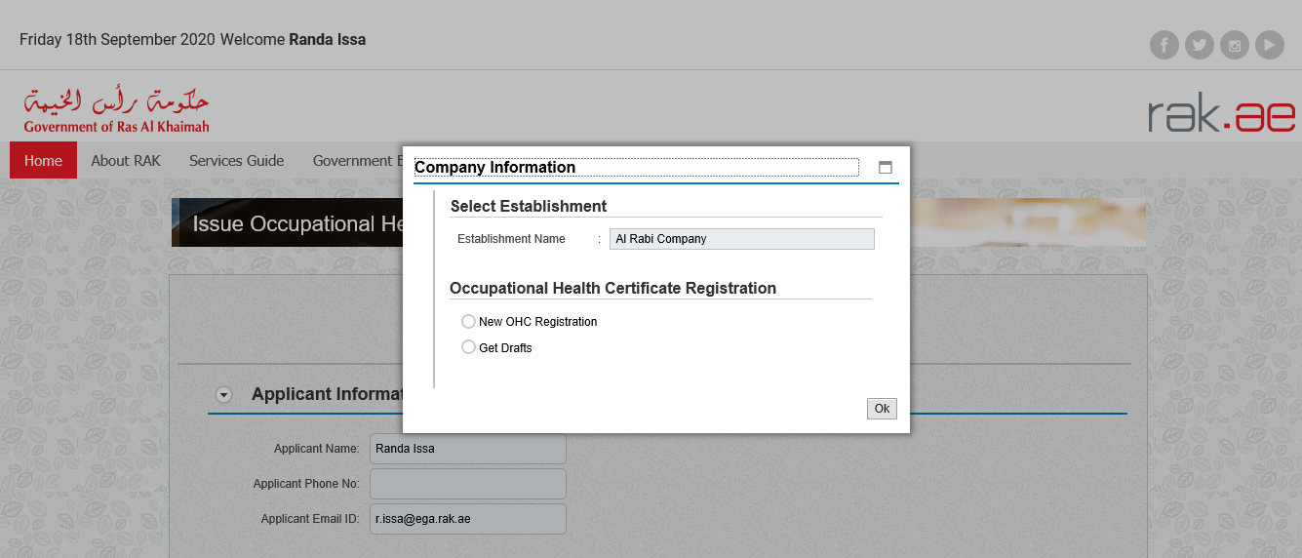

Note:
- If the establishment license is expired, you will not be able to submit the request.
- Though this service the establishment’s representative can apply for:
          - New health certificate for the establishment’s already registered workers.
          - Re-new the health certificate before expiry or Re-new the already expired health certificate for the establishment’s workers.
          - Cancel the workers’ health certificates by representative or by worker.

- Select the establishment for whose workers you want to issue the health certificates, from the Establishment Name dropdown list.
- To create a new OHC request, select the “New OCH Registration” option then click “Ok”:

Then the Issue Occupational Health Certificate request form will be displayed enabling you to create the request:

- View and check your information in the “Applicant Information” block:

- View and check the information of your establishment in the “Establishment Information” block:

Note: to view the establishment’s activities, click on the “Show” button beside the “License Activity” item, then the activities list will pop up as below:
Click the “Close” button to close the screen.

- The “Employee Details” block shows the worker who is already registered in the establishment and need a new OHC, and the worker whose OHC is expired or about to be expired and you should either cancel it or apply for renew (as needed).

Notes:
- In case the worker is new and needs a new OHC, then once the worker is selected, only one option is allowed in the Action field which is (Issue New Occupational Health Certificate)

- In case the worker’s OHC is active but about to be expired or already expired, then once the worker is selected, two options will be allowed in the Action field that are (renew or cancel OHC):

- To issue a new OHC;

  - Select the required worker
  - Enter you remark (if any)
  - Click the “Submit” button:

- To re- new an OHC;

  - Select the required worker,
  - Select (issue renew Occupational Health Certificate) from the Action dropdown field,
  - Enter you remark (if any)
  - Click the “Submit” button:

- To cancel an OHC;

  - Select the required worker.
  - Select (Cancelling Occupational Health Certificate) from the Action dropdown field

  - Click on the “Browse” button, which will be activated only in cancellation case, to attach the mandatory document.

The Upload Attachment screen will pop up as below:

  - Click on the “Upload” button beside the only required document which is the Cancelation letter from MOHRE or the passport and immigration, a window pops up allowing you to choose the files as below:

  - Browse for the file, the Click on Add the file will be uploaded successfully

Notes:
- Once the document is attached successfully, a green tick will appear on its caption.
- To view or delete the attachments, click on the “display” icon to the right of the worker record. Then, the following form will pop up:

- Click on the View Icon to view the document.
- Click on the Delete icon to delete the document.
- You will not be able to issue an OHC for a worker whose visa or passport is expired.
- Enter you remark (if any), then click the “Submit” button:

Notes:

- You can export the establishment’s list of workers into an Excel sheet by clicking on the “Export” button and select “Export to Microsoft Excel”.

- The “Employee Details” block allows you to create a new view for the block as suitable for you through the Setting icon:

To change the block view, follow the steps below:
- Click on the Setting icon at the top right side of the block, to have the Setting screen pop up as below:

- Select the required column to be displayed in the detailed block from Hidden Column, then click on the “Add” button to move them to the Displayed Column.
- Remove the required column from the detailed block by selecting them from the Displayed Column, then click on the “Remove” button to move them to the Hidden Column.
- Organize the view in the displayed columns by selecting the required column caption and move it up , down , to the top , to the last
- Click on the “Apply” button to apply the changes directly on the detailed block.
- Click on the “Ok” to confirm the changes.
- Click “Reset” to clear changes.
- Click on the “Save as” button at the top to save the new changes under view caption, the following screen pops up:

- Enter the description of the new view then select the “Initial View” box if you want the new view to be your default view, then click “ok”.

- After filling the mandatory fields to create new/ re-new/Cancel OHC, you have options to:

- “Save as Draft” to keep the request in your draft for later submission.
- “Back to Initial Screen” to start over a new request.
- “Submit” to complete the request and submit it.

- Click “Submit” and confirm the submission in the displayed confirmation message.

A screen will appear stating that the case is submitted in addition to the case ID.

Notes:
- To get your feedback regarding the service procedure, the following happiness meter screen will pop up along with the request result screen allowing you to submit how happy you were for the same:

- Select the required face and your evaluation will be submitted directly.
- Upon submission, the system will show error messages at the top of the request if there any problem related to any of the workers as below:

- Upon successful submission, an Email will be sent to the applicant stating that the OHC request is submitted successfully and it is pending for payment.

Request fee Payment
After the request is submitted, you need to access My Cases service on the RAK Portal www.rak.ae to pay the request fee. To access the My Cases page and pay the fee your request:

- Click on the “Service Guide” then click on “Government” item.

- Next, select “RAK Municipality”

- Next, Select the “Public Health Department”

- Next, Select “My Cases”

- Next, enter your RAK Government Portal username and password which you have previously created, then press on the “Log in” button.

- “My Cases” tab will be displayed to show all of your transactions submitted to the Public Health Department and pending for PHD approval.

“My Cases” Tab displays the service ID, description, type, applicant, creation date, final decision and the status for each request.

Note: You can do the following for each case/ request created:
- Print (As a Pdf)
- Export (As excel files)
- You will be able to view the details of the service request by selecting the required request and then clicking on the “Case Details” button

The details screen of the selected request pops up to show all of its details as below:

- Select the required request and then click on the “Payment Requests” button.

- The following screen will be displayed to show the amount needed to be paid for the select request.
- Click on the required payment item and then click on the “Pay Selected Item” button to move to the payments channels screen:
The system allows you to pay the required amount of money through different channels like the bank cards or the electronic dirham.
- Select the required payment channel and click the “Pay” button to proceed with the payment process as usual.

Medical Appointment Download

After payment is done successfully, you will receive an email including the medical appointment which you should download and submit it to the medical provider where you should do the required tests.

There are two ways to down load the appointment letter:

- First, from the email you have received upon successful payment, click on the arrow to the right of the attached letter or right click the attached letter, then save it to your desktop and print it out.

- Second, you need to access My Cases service on the RAK Portal www.rak.ae.

  - Select the required request and then click on the “Case Documents” button

  - A screen will pop up to show the documents that are inserted to the selected request (appointment letter).

  - Click the Download icon beside the required document to download it, or click on the “Download all Attachments” button to download all of the attachments at once (if any).

Note: The appointment letter looks like below empty form while the medical test result will be the same form after being filled and stamped by the medical provider:

Medical Results Upload
After receiving the medical result, you have to upload it to your OHC transaction on My Cases service (My Notification tab) on the RAK Portal www.rak.ae.
To access “My Notification” tab, follow the same procedure you did to reach “My Cases” Tab.
To upload the medical result, follow the steps below:
- Click on “My Notification” tab, to view your requests that are pending for your actions there:
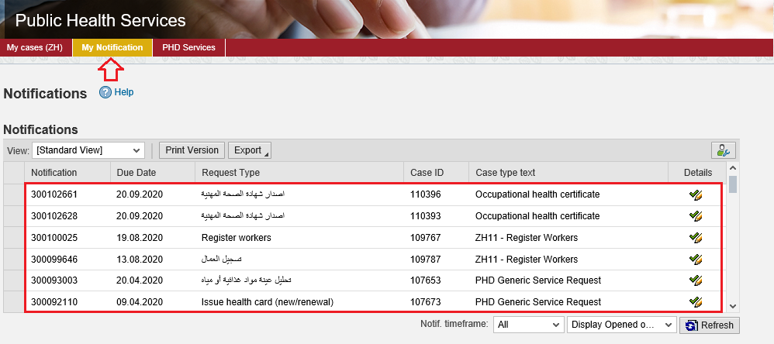

- Click the “Details” icon to the right of the OHC required request the “Customer Action” screen pops up as below:
- Read the notes of the PHD customer happiness employee.
- Click on “Open Case” button the request details screen opens
- Click on the “Browse” button to upload the test result on the request form, then click “upload” in the next pop up to upload the “Employee medical test result”, the click on “Add”.

- Click the “Update” button. A confirmation message will pop up:

- Click “Yes”, then you will return to the “Customer Action” screen:

- Click “Complete” and then “Save” to complete your request the request will be removed from “My Notifications” tab and the request will be submitted to the PHD employee for review and take the decision as follows:
- Accept the request, if the result was “Fit”, after which you will receive a confirmation message SMS and the OHC certificate will be sent to you via email.
- Reject the request, if the result was “unfit”, after which you will receive an email and a short message SMS for the same.
- Return the request for modification after which you will receive an email and a short message SMS for the same. In addition, you should modify the request as per the notes then re-send it to the employee to review it again and take the appropriate action against it.

Create an Occupational Health Certificate Request from Draft
If you have created an Occupational Health Certificate request before and saved it as a draft, you can open it and submit it any time instead if create it again as below:

- After you access the Occupational Health Certificate and click on the “Start Service” button, the login page will appear as follow:

- Enter your RAK Government Portal username and password which you have previously created, then press on the “Log in” button.
- The Company Information form will be displayed:

- Select the establishment from the Establishment Name dropdown list.
- Select “Get Draft” option and click “OK”:

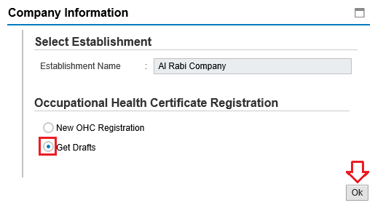

Then, the List Draft cases will be displayed as below:

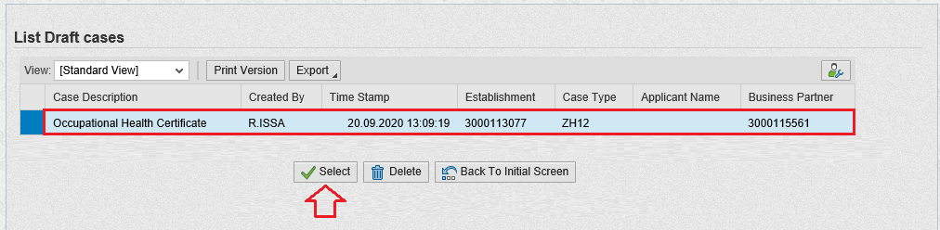

- Select the required draft and click on the “Select” button to open it and complete with the request update and submission as explained before.
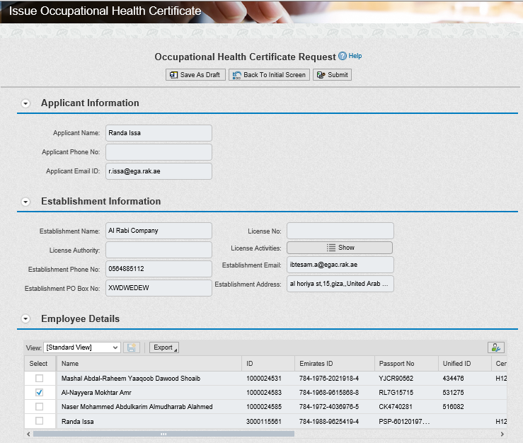

- To delete a request draft, select the required draft and click on the “Delete” button:

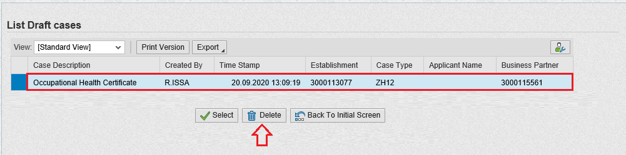

Customer Action
Upon successful submission the request will be displayed for the PHD customer happiness employee to review it and take the decision, but if the request requires a modification from the applicant, then the employee will return it to the applicant to apply the modification and send it again after modification for review.
When your request is returned to you for modification, you will find it in “My Notification” tab. To access “My Notification” tab, follow the same procedure you did to reach “My Cases” Tab.
In “My Notification” tab, you can open the request for modification as in the screen below:
To modify a request, follow the step below:
- Click the “Details” icon to the right of the required OHC request the “Customer Action” screen pops up as below:
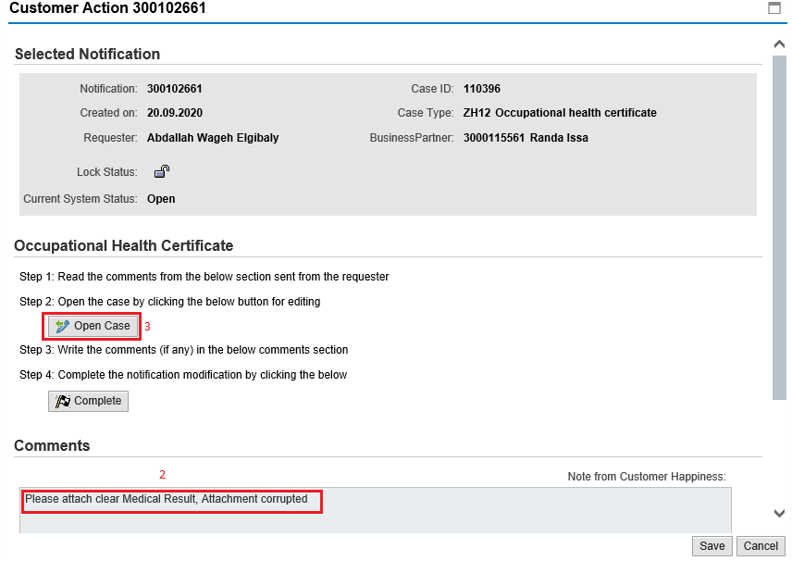
- Read the notes of the PHD customer happiness employee.
- Click on “Open Case” button to modify the request the request details screen opens
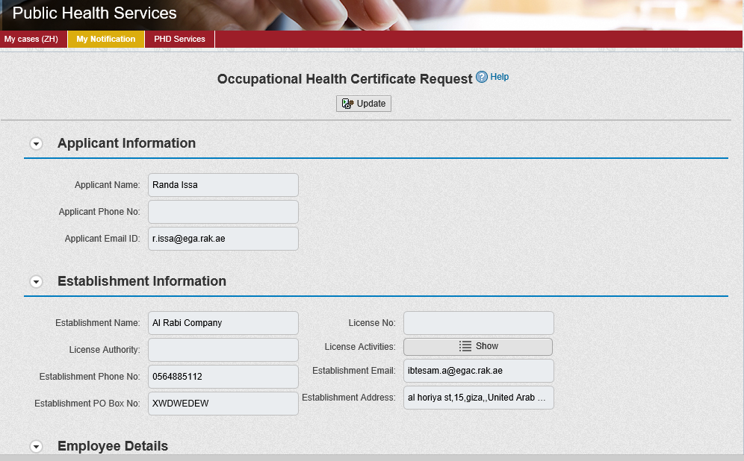
- Modify the request as per the employee comments through add/replace or delete the request attachments. In addition, you can add remarks.
- Click the “Update” button. A confirmation message will pop up:

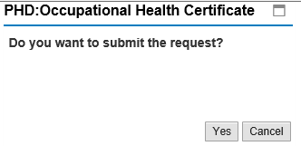

- Click “Yes”, then you will return to the “Customer Action” screen:

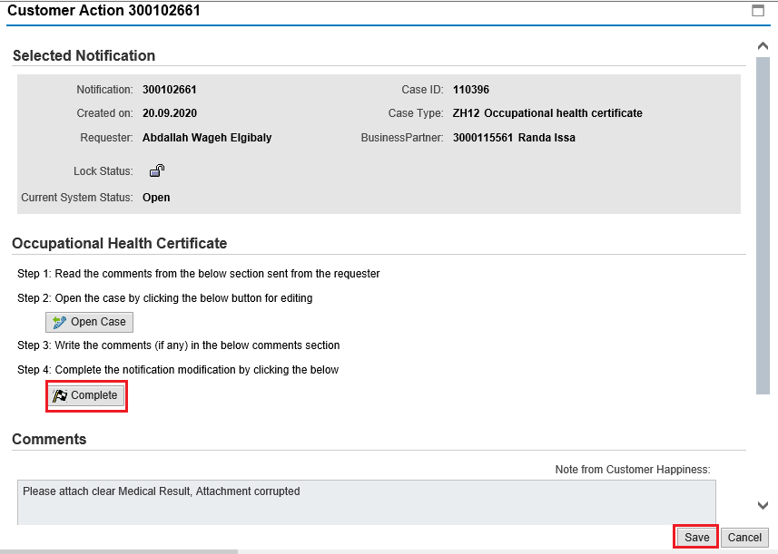
- Click “Complete” and then “Save” to complete your modifications the request will be removed from “My Notifications” tab and the request will be submitted again to the PHD employee for review and take the decision.

After getting your request approved by the customer happiness employee, you will receive a confirmation short message SMS stating that the OHC is issued successfully, also you will receive the approved OHC via Email as below:

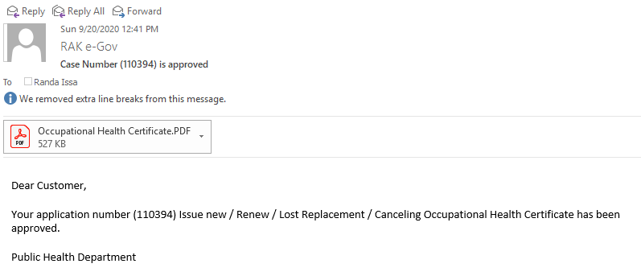

The attached Occupational Health Certificate will look like below:

