User Manual
Renewal Ownership Document Request
Land and Property Section

Contents:

- Introduction: 3
- Login and access to the Renewal Ownership Document Service 4
- Create Renewal Ownership Document Request 7
- My Cases 15
- Fee Payment 21
- Customer Action 23

Introduction:

The land and property section in Ras Al Khaimah Municipality launched a set of electronic services to save customers time and effort and enable them to submit their requests at any time and from anywhere.

The Renewal ownership document service allows the owners of properties to renew ownership due to updated details on site plan, after attach the required documents and pay the required service fee.

This guide shows customers how to access the Renewal ownership document service. It also guides them on how to create, send and track the request electronically.

Customers will be able to log in to the electronic services of the section, submit requests, track requests, modify requests (if necessary), re-submit the requests after applying the modifications electronically, and finally obtain their required certificates either electronically or by receiving them from the Customer Happiness Center as per the need for the original copy.

Login and access to the Renewal Ownership Document Service

- Once Navigate to the RAK Government portal on https://www.rak.ae/wps/portal
- To access the Renewal Ownership Document service, click on the “Service Guide” then click on “Government”
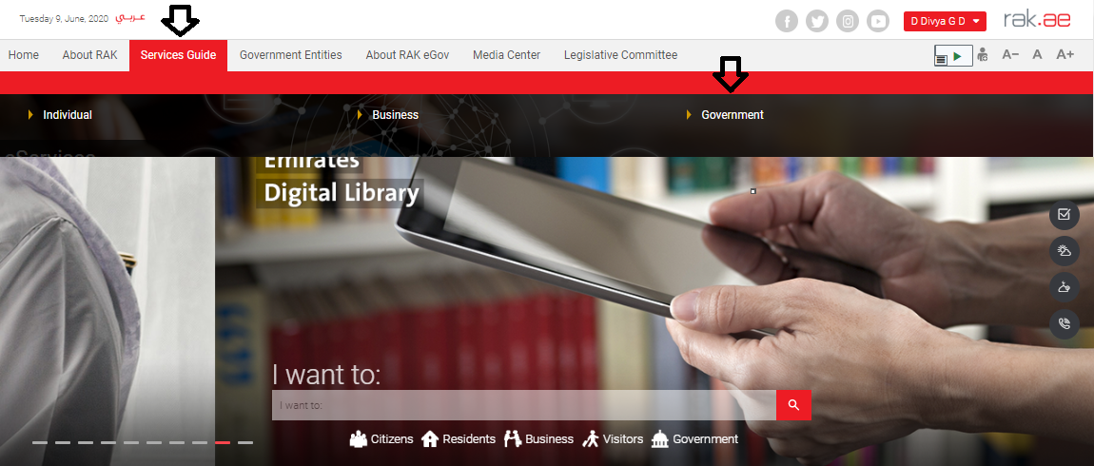

- Next, select “RAK Municipality”
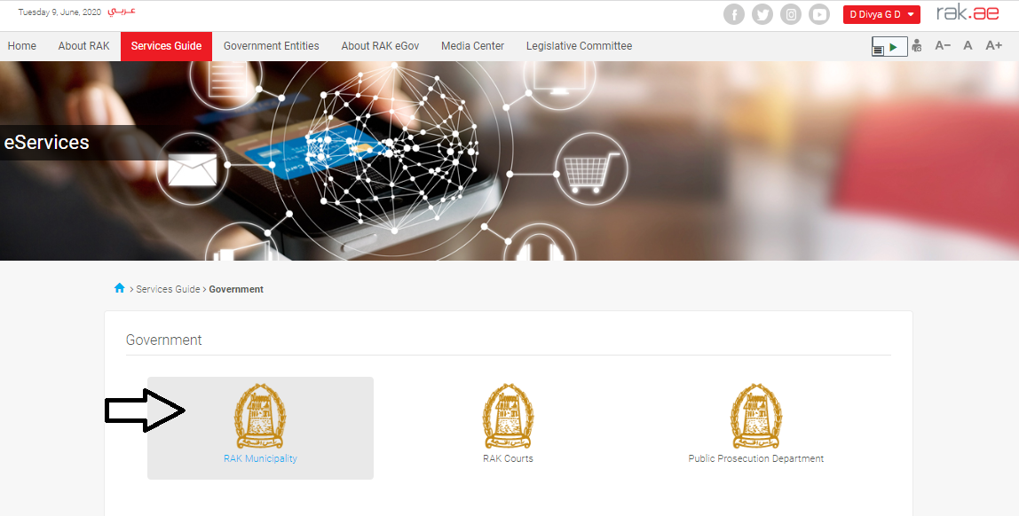
- Next, select “Land and Properties Section”

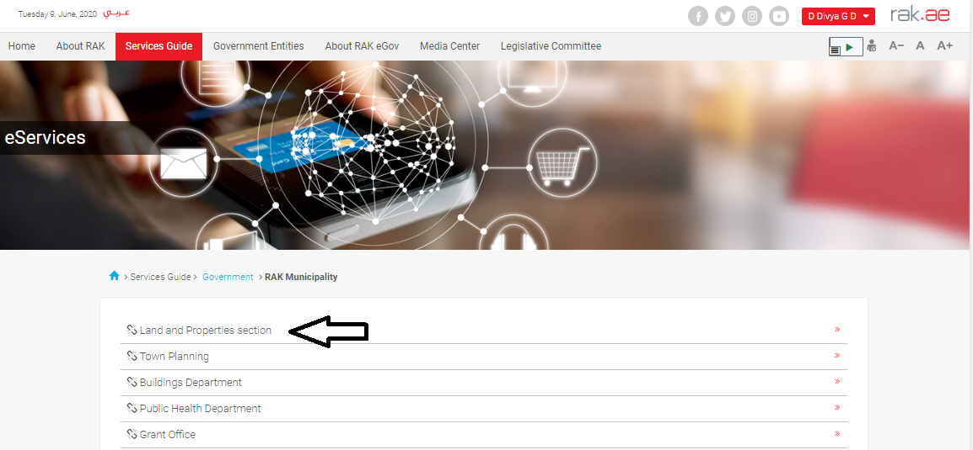

- Next, click on Title Deed Renewal

- The service screen displays the service definition, procedure, conditions, fees, time, and the required documents.

- To use the service, click on the “Start Service” button.

Create Renewal Ownership Document Request

- After you access the Renewal Ownership Document service and click on the “Start Service” button, the login page will appear as follow:
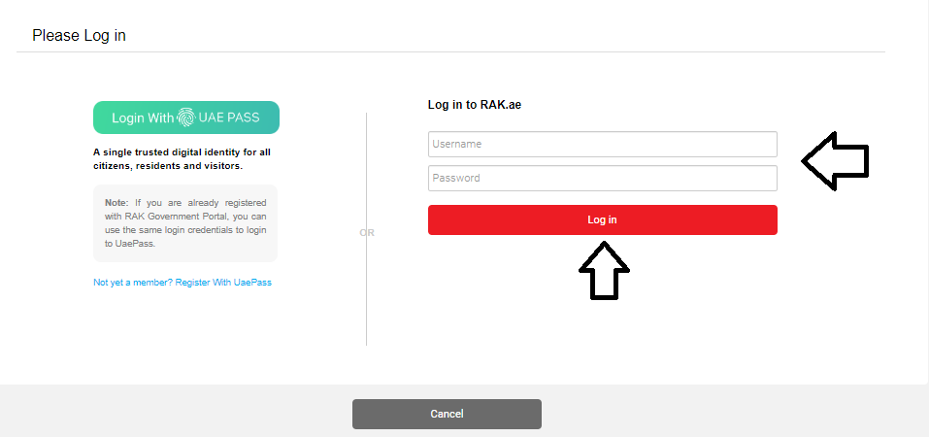
- Enter your RAK Government Portal username and password which you have previously created, then press on the “Log in” button.
- The Renewal Ownership Document request form will be displayed enabling you to create the request:

- In General Information block, select the Ownership Type, from the dropdown list:
- Enter the site plan number in the " Site plan ID " fields in (number / year) format.
- Enter the land register number in the "Land Register" fields in (number / year) format, then click the "Enter" key to have the parcel land number displayed in the "Parcel Land " field automatically, as well as the list of the land’s owners will be displayed in the " The list of Owners”

Notes:
- All fields that are preceded by an asterisk are mandatory fields.
- If the land register is older than 2014, the system may request you to specify the type of the ownership, whether it is transfer or proof ownership:
Check your ownership type from its’ header, select the correct type, then click "OK" to continue with the request
- As you login to the service, the system will display your name and number in the “Applicant” fields automatically.
- In case the system asks you to update your information, click on the “Update” button next to the “Applicant” field to display “Create new Business Partner” screen through which you can update your information as below:
- Select the appropriate way of search from the dropdown menu of “Search Criteria”, then enter the required inputs as follows:
The dropdown menu includes many search options and upon your selection, the required inputs will be changed as follows:

Required inputs | Search way
Search by the Emirates ID, then enter:
- EID number
- Select the nationality
- Select the date of birth
Search by the passport number (for non-Emirates ID holders), then enter:
- Passport number
- Select the Passport type
- Select the nationality
- Select the date of birth
Search by the unified ID (for non-Emirates ID holders) then enter:
- Unified number
- Select the nationality
- Select the date of birth
Search with the Trade license number (issued by the Government of Ras Al Khaimah) and then enter:
• license number

- Enter the code that appears in the figure, then click on “Ok” below the figure to ensure the code.
Note: enter “Refresh” button to get a new clearer code, or click on “Cancel” button to clear the input and re-write the code again.

- In the Attachments block you have to attached all of the mandatory documents to complete the request. You also, can edit all attachments (add new or remove/replace existing).
- To upload documents:

- Click the “Add New” button, a window pops up allowing you to choose the files as shown below:
- Select the name of the document to be attached from the “Document Type” drop down list:
Notes: You must attach all documents in the list except:
- "Limitation of Inheritance ", which must be attached in case the original owner of the property is dead, hence the Emirates ID of all the heirs should be attached as well.
- Browse for the file and Click on Add the file will be uploaded successfully.
- Repeat the steps to attach next documents.
Note: In case of incorrect upload, you can select the record and click the “delete” button to remove it

- Enter your notes in the “Notes” field
- You have the following options to do:
- “Submit” to complete the request.
- or clear all fields by selecting “clear”

- Click “Submit” and confirm the submission in the following confirmation message.
A screen will appear stating that the case is submitted successfully including the case ID.

- To apply for a new service, click “New Case”

After the request is submitted, you need to access your cases on the RAK Portal www.rak.ae to track your request and pay the required fees after getting the request approved, then your request will be approved and the replacement ownerships will be printed, then you can visit the customer happiness center in RAK municipality to get the original copy.

Note: To get your feedback regarding the service procedure, the following happiness meter screen will pop up along with the request result screen allowing you to submit how happy you were for the same:
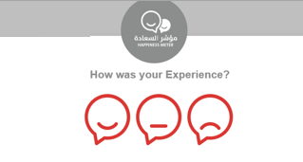
Select the required face and your evaluation will be submitted directly.

My Cases

When you submit the Renewal Ownership Document request, it is received by the coordinator in the land and property section to review it and accordingly the coordinator will do one of the following actions:
- Accept the request, after which you have to pay the fees.
- Reject the request stating the justifications.
- Return the request for modification after which you must modify the request as per the notes then re-send it to the coordinator to review it again and take the appropriate action against it.
Note: when the coordinator take one of the above mentioned actions, the system will notify the customers by sending SMS on their mobile phones and Emails to let them know that their request is accepted initially, then the request will be either approved, rejected or needs modifications.

You can find the submitted requests in “My Cases” tab, to access it please visit the Ras Al Khaimah Government website at www.rak.ae as shown on the screen below.

Then, Click the “Service Guide” then click “Government”:
Next, select “RAK Municipality”
Next, Select the “Land and Properties Section”

Next, Select “My Services”

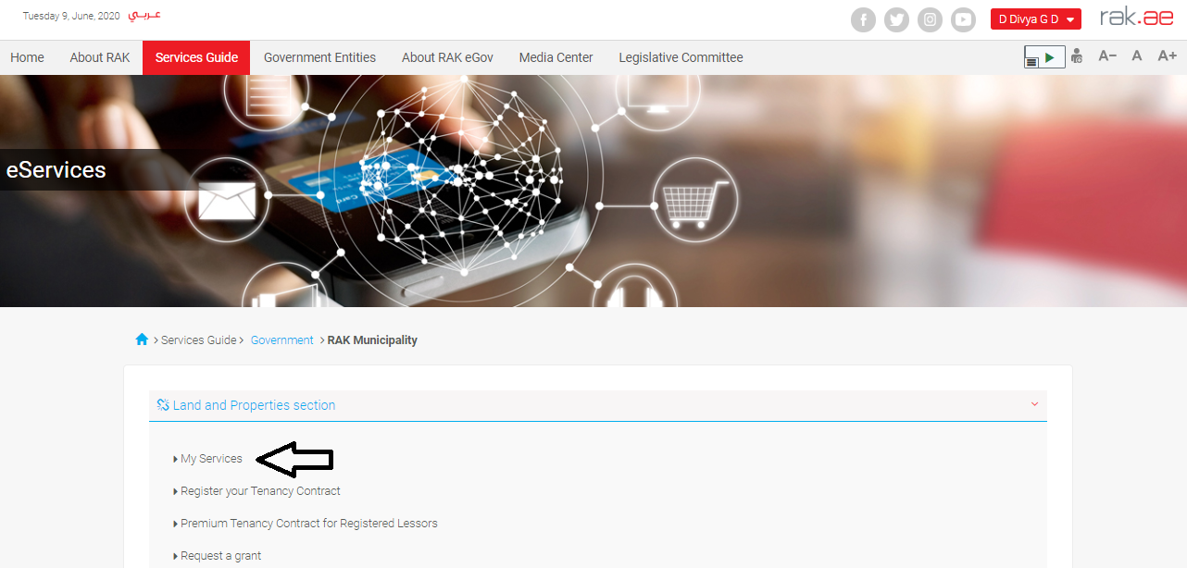

Next, Enter your RAK Government Portal username and password which you have previously created, then press on the “Log in” button.

“My Cases” tab will be displayed to show all of your transactions submitted to the land and properties section and pending for payment (if not paid yet) or pending for coordinator action.

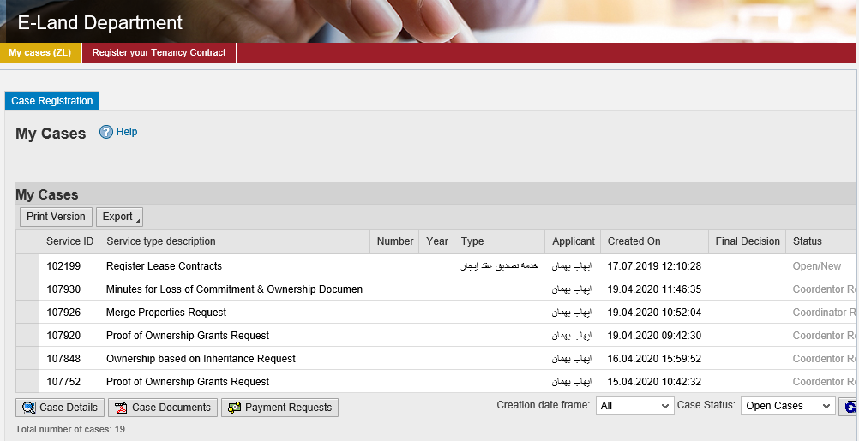
“My Cases” Tab displays the service ID, description, type, applicant, creation date, final decision and the status for each request.

Note: you can do the following for each case/ request created:
- Print (As a Pdf)
- Export (As excel files)
When selecting the request, and perform any of Print version or export, the system will automatically generate / download the required case

- You will be able to view the details of the service request by selecting the required request and then clicking on the “Case Details” button
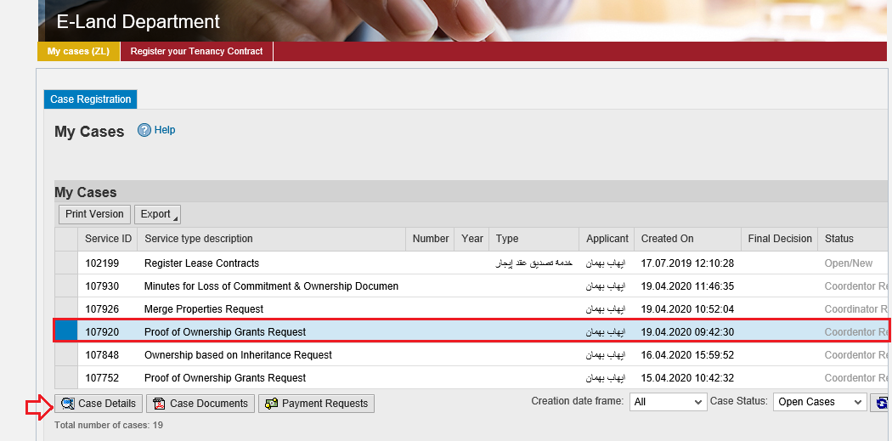

The details screen of the selected request pops up to show all of its details as below:

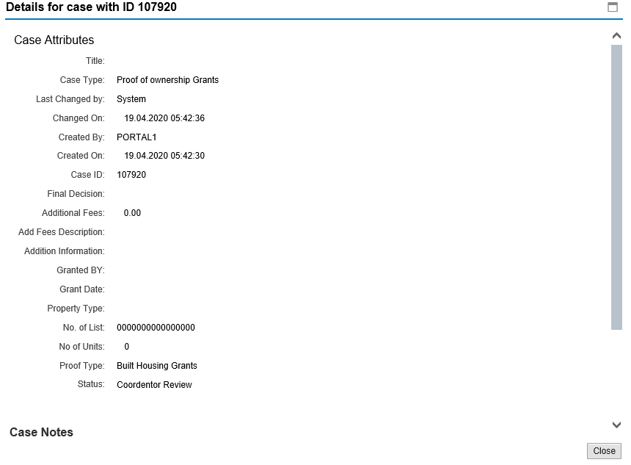

- You will be able to view the attachments of the service request by selecting the required request and then clicking on the “Case Documents” button
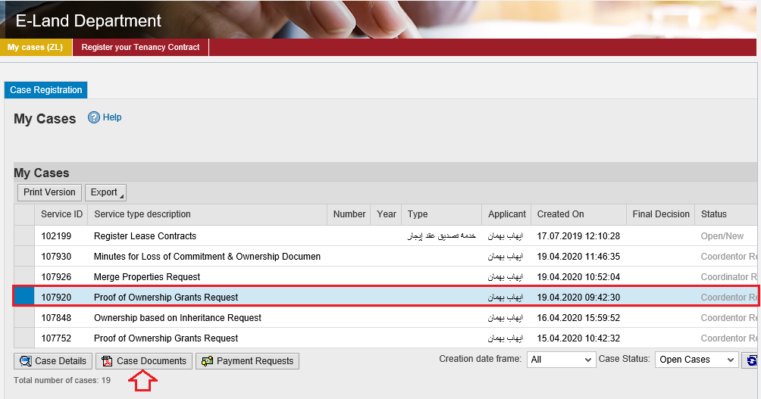
A screen will pop up to show all of the documents that are attached to the selected request when it is created where you can upload any file or all of the files.

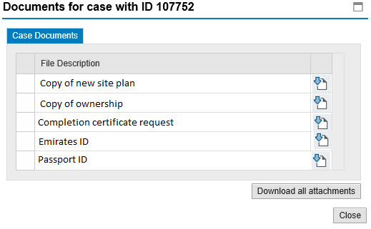

Fee Payment
After the coordinator of the land and properties section accepts your request, the system will notify you to pay the request fees via email and SMS, so in “My Cases” page you will select the request whose status is “pending for payment” and then click on the “Payment Requests” button.

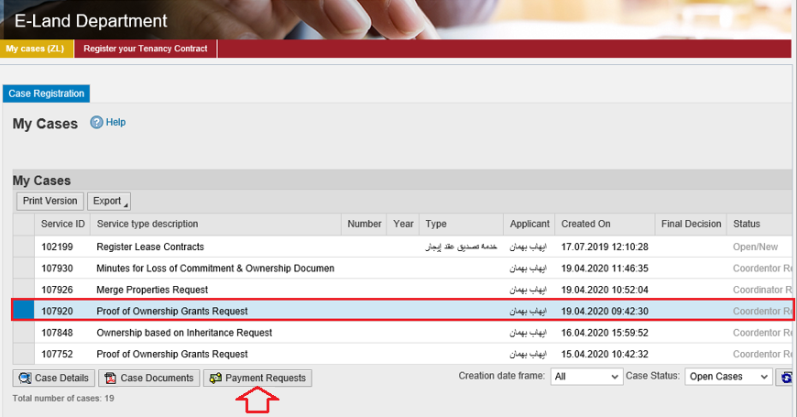
The following screen will be displayed to show the amount needed to be paid for the select request.
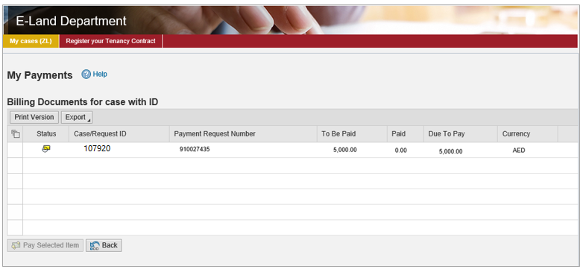
Click on the required payment item and then click on the “Pay Selected Item” button to move to the payments channels screen:
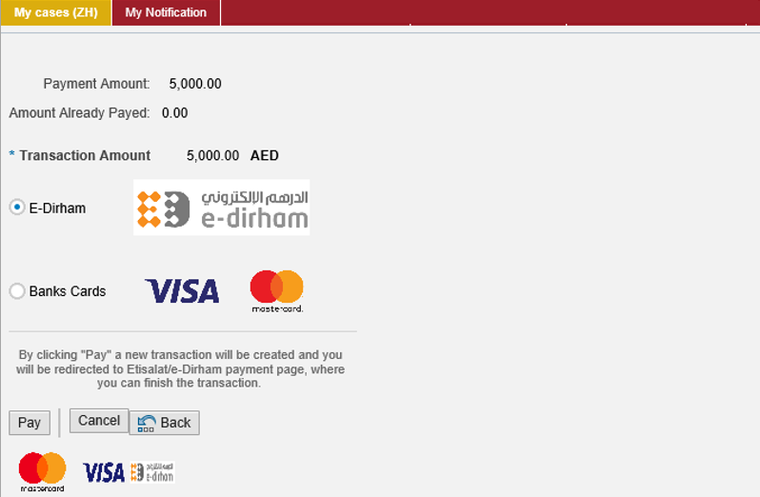
The system allows you to pay the required amount of money through different channels like the bank cards or the electronic dirham.
Select the required payment channel and click the “Pay” button to proceed with the payment process as usual.

Customer Action
Upon successful submission, the request will be displayed for the land and properties coordinator to review it and take the appropriate action, but if the request requires modifications, then the coordinator will return it to the customer to apply the modification and send it back again for review.
When one of your request is returned to you for modification, you will find it in “My Notification” tab. To access “My Notification” tab, follow the same procedure you did to reach “My Cases” tab.
In “My Notification” tab, you can open the request for modification as in the screen below:
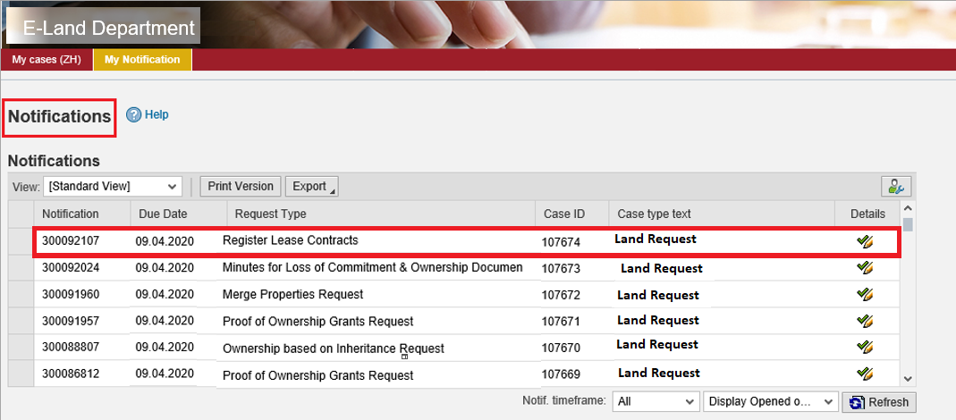
To modify a request, follow the step below:
- Click the “Details” icon to the right of the required request the “Customer Action” screen pops up as below:
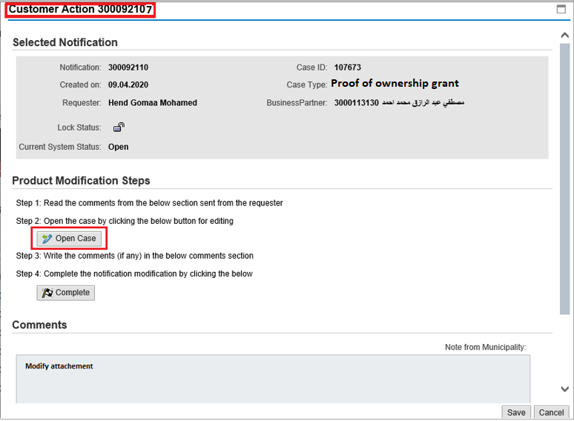
- Click on “Open case” button to modify the request the request details screen opens
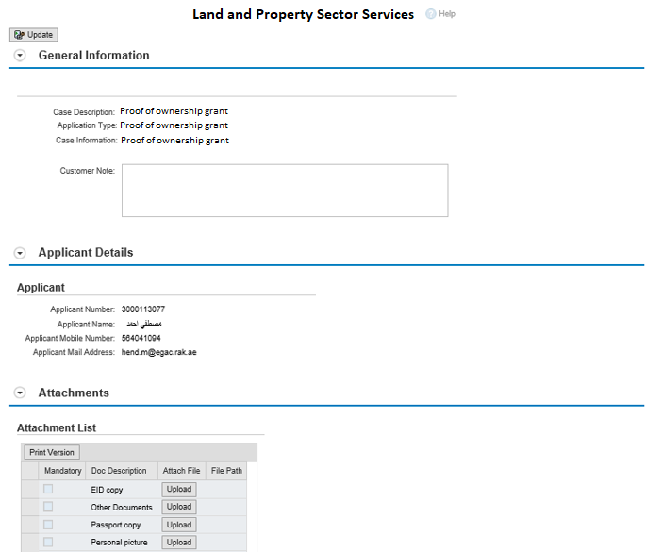
- Modify the request as per the coordinator comments.
- Click the “Update” button. A confirmation message will pop up:
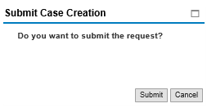
- Click “Submit”, then you will return to the “Customer Action” screen:
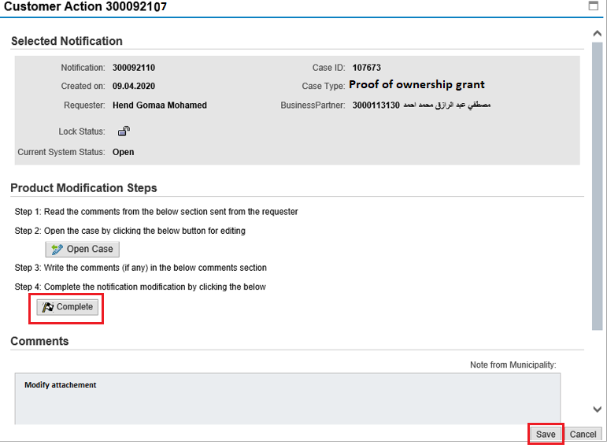
- Click “Complete” and then “Save” to complete your modifications the request will be removed from “My Notifications” tab and the request will be submitted again to the land and properties coordinator for review.

After your request gets the final approval, you will be notified via SMS and Email that your request is approved and you can receive the new ownership from the customer happiness centre in the RAK municipality.

