User Manual
Online Services
Public Health Department

Contents:

- Introduction: 3
- Creating a New Account on SmartPass 3
- Log in and Create PHD Online Service Request 13
- My Cases 18
- Request Payment 23
- Customer Action 25
- Appendix i 29

Introduction:
The Public Health Department of Ras Al Khaimah has published a patch of online service to save the customers time and efforts, and to enable them to submit any request anytime from anywhere. Hence, the customer should have a registered account on the Public Health Department to be able to use those online services.
This manual will guide the customer on how to register online account and how to use it to reach the PHD online services. In addition, it will guide the customer on how to create, submit, and track their PHD requests online.
The customer will not visit the DHP facility at any time, the customers can register their online accounts, submit requests, track requests, modify requests, re-submit request after modifications, and finally get their required certificates all online.

Creating a New Account on SmartPass
The first step you need to do is to have an account on the SmartPass, as follows:
- Access https://smartpass.government.ae
- Log in or create a new user

- When a new account is registered on SmartPass without Emirates ID, the customer should visit a SmartPass Kiosk to update the Emirates ID Card and register the user's fingerprint.
- After completing the registration, navigate to RAK Government website https://www.rak.ae/wps/portal.

- Log in using the same user account registered on SmartPass to complete your registration.
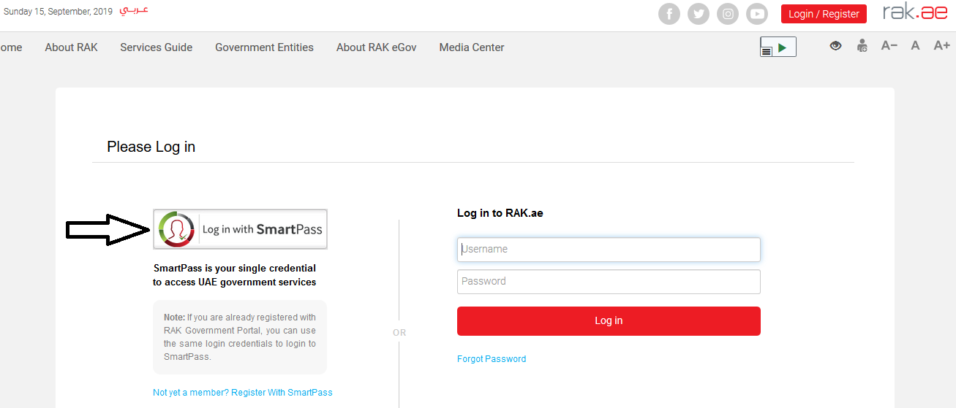

- Use the same username and password registered on SmartPass to activate the account.

- Once registration on SmartPass is completed and you have accessed the RAK Government portal, submit the establishment identification documents to register the establishment online.
- The required documents for establishment or individual registration can be found on the RAK Government portal by clicking the “Service Guide” then clicking “Government”
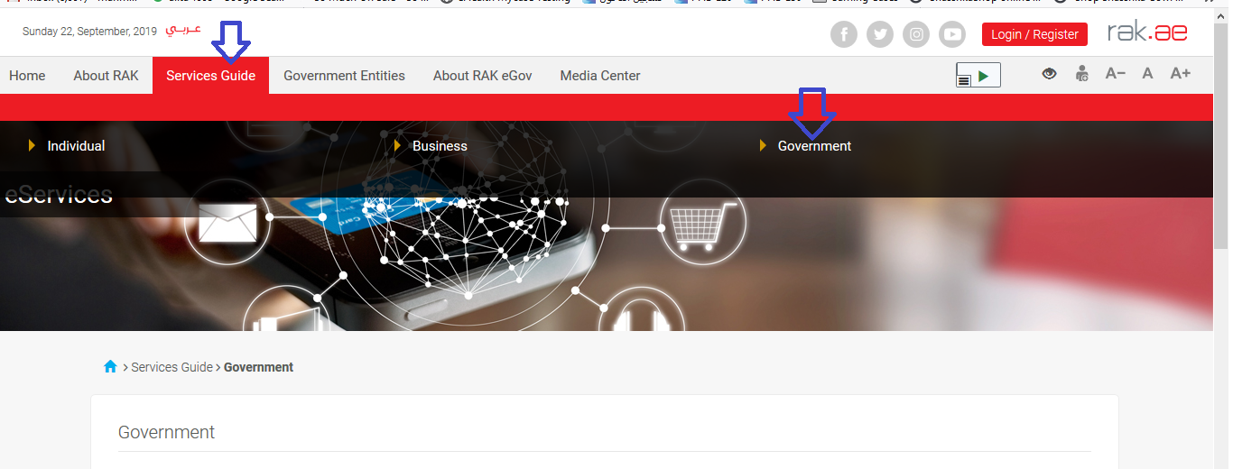

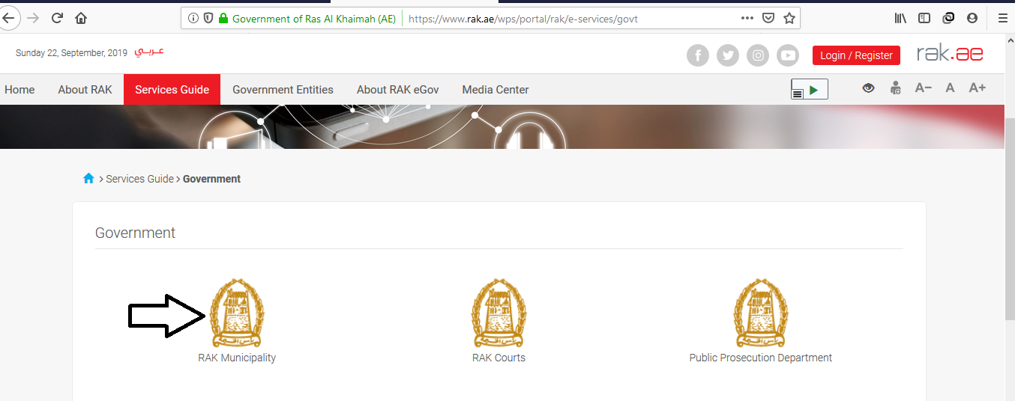
- Next, select “RAK Municipality”

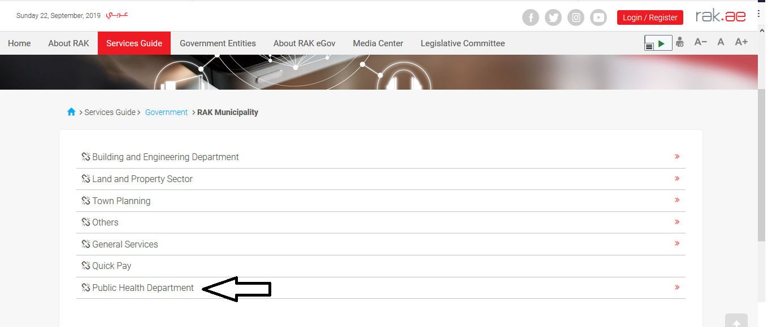
- Next, select “Public Health Department”
- Next, click on Public Health Department Online Services

- The PHD online service screen displays the online service definition, procedure, prerequisites, fees, time, required documents and the required forms to be downloaded.

Important Note: to view the list of all the online services that are provided through this screen, their fees, and their required attachments, please download the “PHD online services prices” sheet that is located at the bottom of the screen.

- You have to download the “Establishment update information form” template located at the bottom of the screen; to fill it and submit it in addition to the rest of the prerequisite documents to have you or your establishment registered in the PHD online service.

Important Note: the rest of the prerequisite documents that are required to register your Establishment/update its information for the 1st time, are the below in addition to the Establishment update information form that you already filled:

  - Copy of the License
  - Lease Contract/ Title Deed
  - Filled Establishment update information form for (Owner / manager / Representative contacts, EID number)
  - Letter of Authorization from the Company (if registering a company representative) with the ID/ Passport Number, full name and representative’s relation to the Company
N.B. In case Manager / owner is not mentioned in license

The Customer must also register a company representative (an individual) by providing the following documents:
  - Create an Internet user (Electronic Company Representative) and SmartPass account by:
    - Registering in SmartPass, scanning the ID Card and fingerprint on a self-payment machine as shown in the first steps
    - A valid Emirates ID Card is needed for the request
  - Provide a letter of authorization from the Company including the company representative’s name, ID/Passport number and contact information
  - Provide the representative’s ID/Passport number

- After having your documents ready, you need to register online in order to be able to use the PHD online services. So, click on the “Start Service” button.

- The “Company Information” screen will pop up as follows:

- Your name will be displayed in the “Applicant Name” field, select the “New Registration” option, and then click “Ok”.
- The Public Health Department Online Service screen will be displayed including the following blocks:
  - The General Information block
Note that the only request type available for you as a new customer is the “Business Partner Update Information” request which you will submit to register your account for the PHD online services. You can enter any notes in the “Customer Note” field.
  - The Applicant Details Block
Note that this block displays your information.
  - The Attachments Block

Note that all of the required documents for your first registration is listed, all you have to do is to upload them and click on the “Submit” button at the bottom of the form, to send your request to the PHD employee for approval.

Important Note: the registration service will be the only active service for the customer when the customer register for the first time.

Log in and Create PHD Online Service Request
After your registration request for the first time is completed and approved by the PHD respective staff, you can login to start using the PHD online services (as needed)

- Enter your SmartPass username and password at www.rak.ae

- Select the name of the establishment for which you want to get the service.
Note that the list will include the establishments that are registered by your username.

- Select “New Registration” option to apply for a new service, then click “Ok”.

Note: you can select “Get Drafts” option, if you have created service request draft before and you want to complete and submit them now, then click “Ok”.

- The Public Health Department Online Service screen opens, and you can apply for a new service.

- In General Information block, Select the Request Type, from the dropdown list which includes 52 requests types.
- Enter your notes in the Customer Note field.

Note:
- The “Case Description” and the “Case Information” fields content will be changed as per the selected request type.
- The Applicant Details block displays the information of the establishment that you have selected in the initial screen, and the information of its representative.

- The Attachments block displays the mandatory documents to be attached to complete the selected request. The list of the attachments will be changed as per the selected request type.
- You can edit all attachments (add new or remove/replace existing) taking into consideration that mandatory attachments should be uploaded.
- To upload documents:
- Click the “Upload” button, a window pops up allowing you to choose the files as shown below:
- Browse for the file and Click on Add the file will be uploaded successfully.
- Repeat the steps to attach next documents.
Note: In case of incorrect upload, you can select the record and click the “Clear” button to remove it

- After you select the required request type, enter your note, and attach the mandatory documents, you have options to:
- “Save As Draft” to save the request for later.
- “Submit” to complete the request.
- or even clear all fields by selecting “Back To Initial Screen” and confirm leaving the screen in the displayed confirmation message.
- Click “Submit” and confirm the submission in the displayed confirmation message.
A screen will appear stating that the case is submitted in addition to the case ID.
- To return to the main screen click “Back”
- To print out the screen click “Print Result Form”

After the request is submitted, you need to access your cases on the RAK Portal www.rak.ae to pay the request fees, in order to send it to the PHD respective employees to review it and take the decision.

Note: To get your feedback regarding the service procedure, the following happiness meter screen will pop up along with the request result screen allowing you to submit how happy you are for the same:
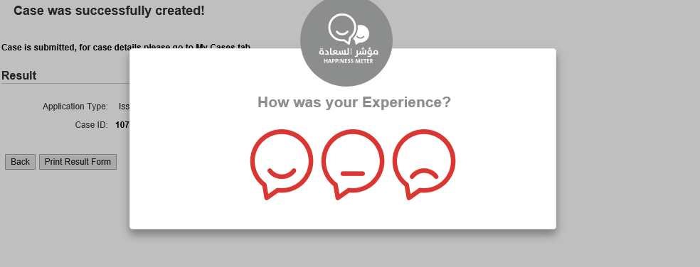
Select the required face and your evaluation will be submitted directly.

My Cases

You can find the Submitted requests in “My Cases” tab, to access it please visit the Ras Al Khaimah Government website at www.rak.ae as shown on the screen below.

Then, Click the “Service Guide” then click “Government”
Next, select “RAK Municipality”
Next, Select the “Public Health Department”

Next, Select “My Cases”

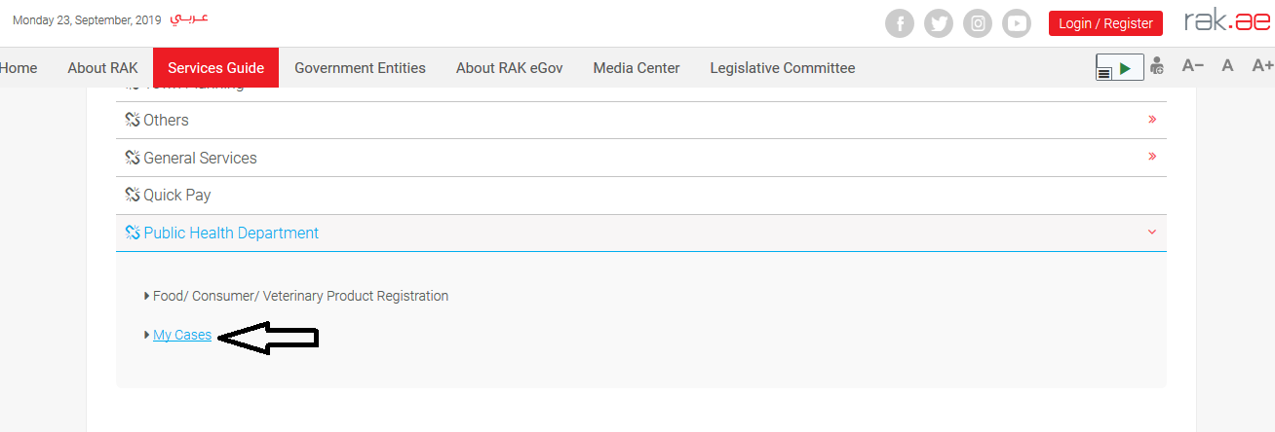

Next, Enter your SmartPass username and password.

“My Cases” tab will be displayed to show all of your transactions submitted to the Public Health Department and pending for payment (if not paid yet) or pending for PHD approval.

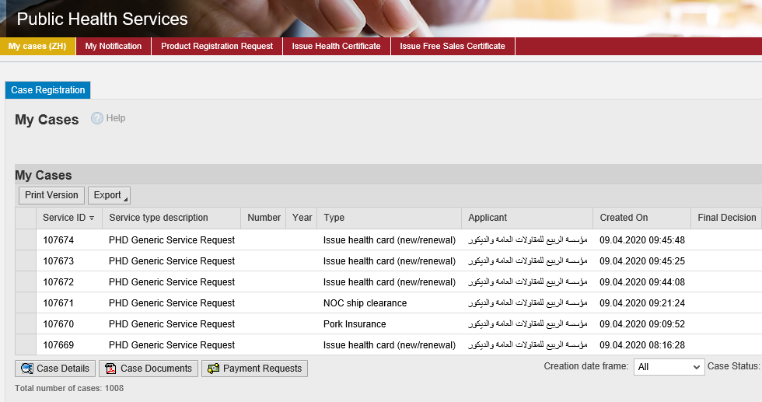
“My Cases” Tab displays the service ID, description, type, applicant, creation date, final decision and the status for each request.

Note: you can do the following for each case/ request created:
- Print (As a Pdf)
- Export (As excel files)
When selecting the request, and perform any of Print version or export, the system will automatically generate / download the required case

- You will be able to view the details of the service request by selecting the required request and then clicking on the “Case Details” button
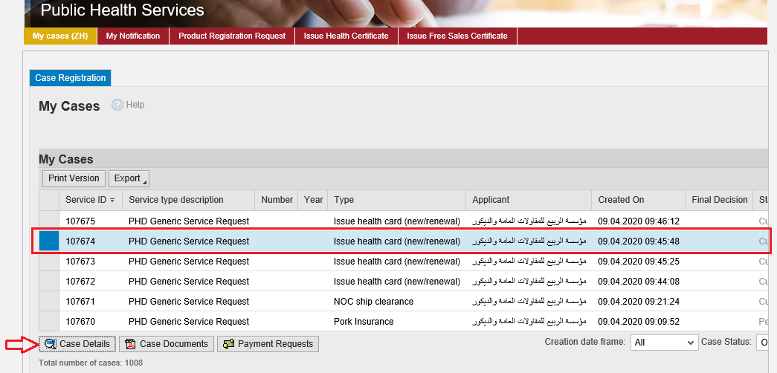

The details screen of the selected request pops up to show all of its details as below:

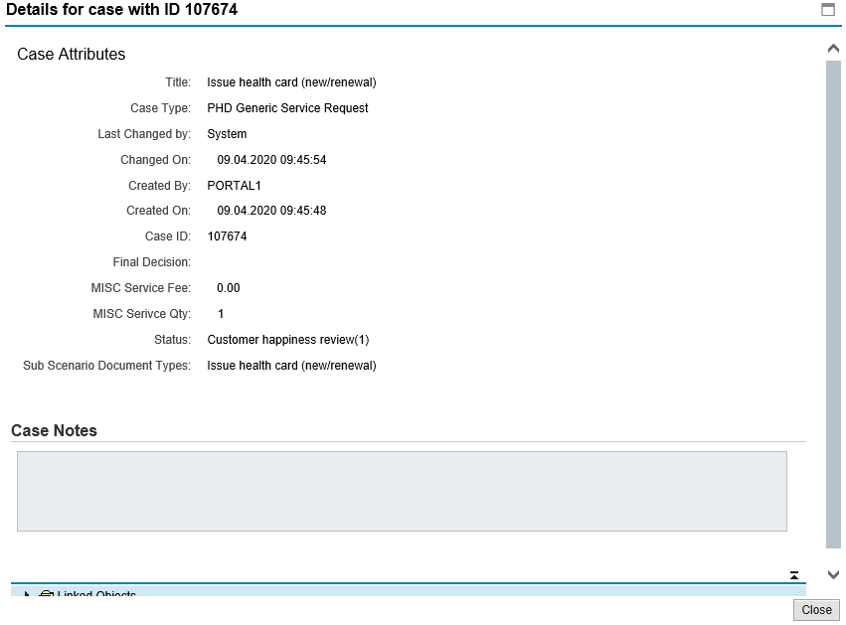

- You will be able to view the attachments of the service request by selecting the required request and then clicking on the “Case Documents” button

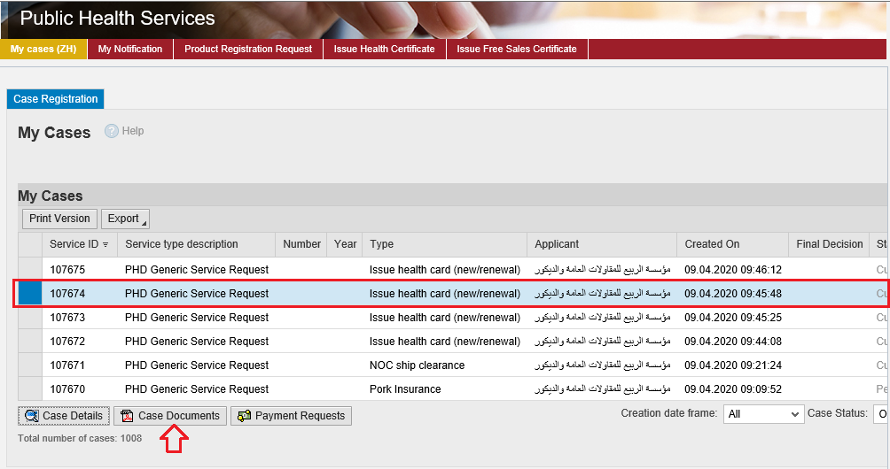

A screen will pop up to show all of the documents are attached to the selected request when it is created where you can upload any file or all of the files.

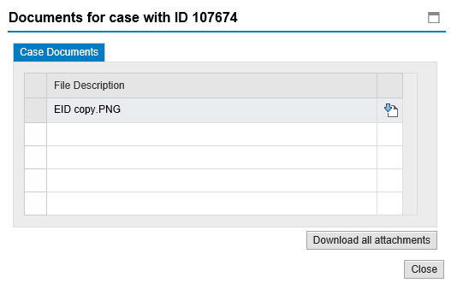

Request Payment
In “My Cases” tab, you will be able to pay the fees of a service request by selecting the required request and then clicking on the “Payment Requests” button.

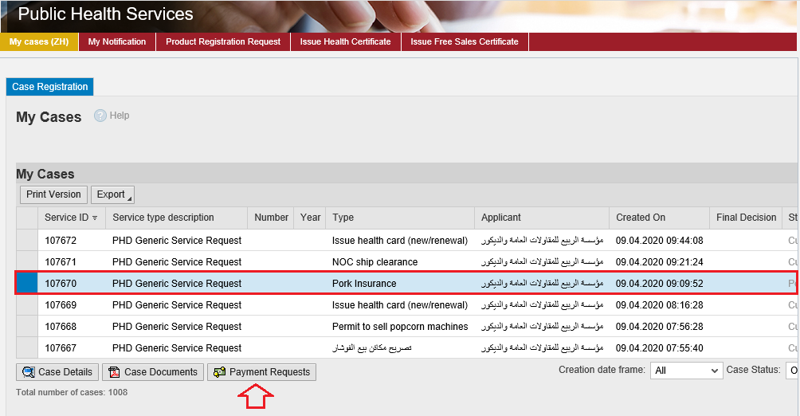

The following screen will be displayed to show the amount needed to be paid for the select request.
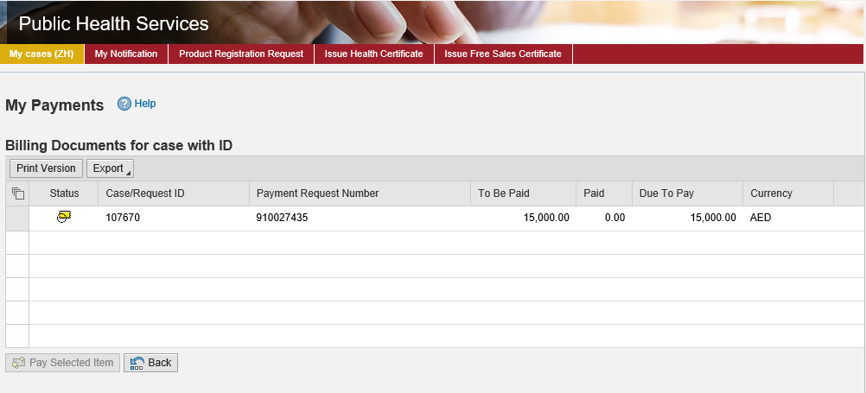
Click on the required payment item and then click on the “Pay Selected Item” button to move to the payments channels screen:
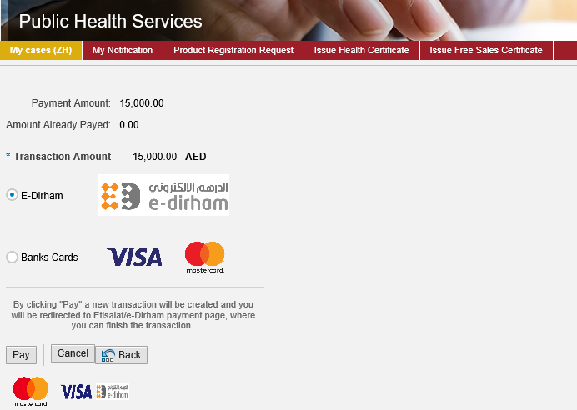
The system allows you to pay the required amount of money through different channels like the bank cards or the electronic dirham.
Select the required payment channel and click the “Pay” button to proceed with the payment process as usual.

Customer Action
Upon successful payment the request will be displayed for the DHP respective employee to review it and take the decision, but if the request requires a modification from the customer, then the employee will return it to the customer to apply the modification and then send it back after modification again for review.
When one of your request is returned to you for modification, you will find it in “My Notification” tab. To access “My Notification” tab, follow the same procedure you did to reach “My Cases” Tab.
In “My Notification” tab, you can open the request for modification as in the screen below:
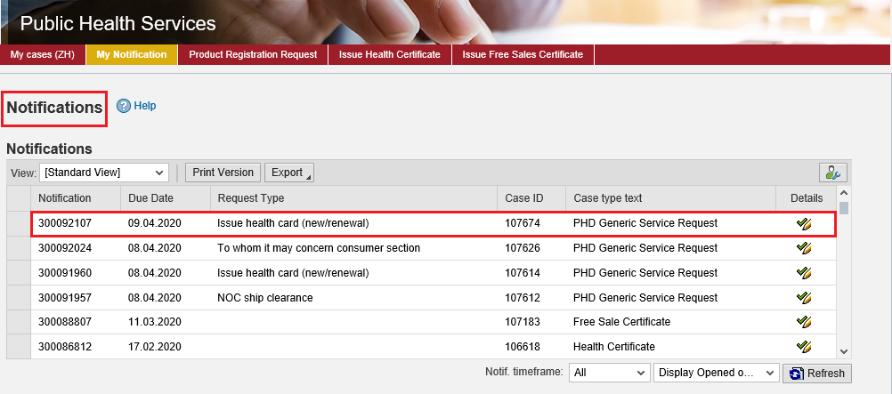
To modify a request, follow the step below:
- Click the “Details” icon to the right of the required request the “Customer Action” screen pops up as below:
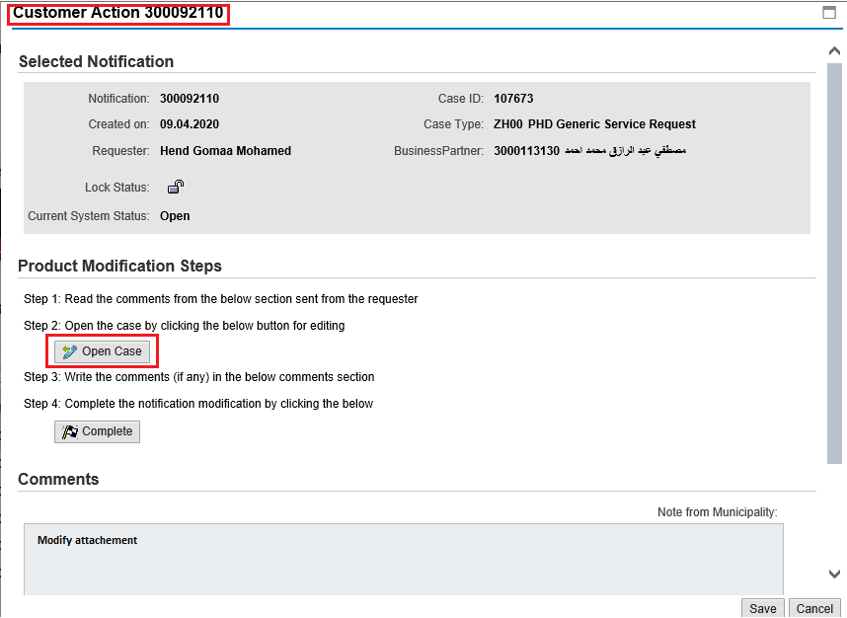
- Click on “Open case” button to modify the request the request details screen opens
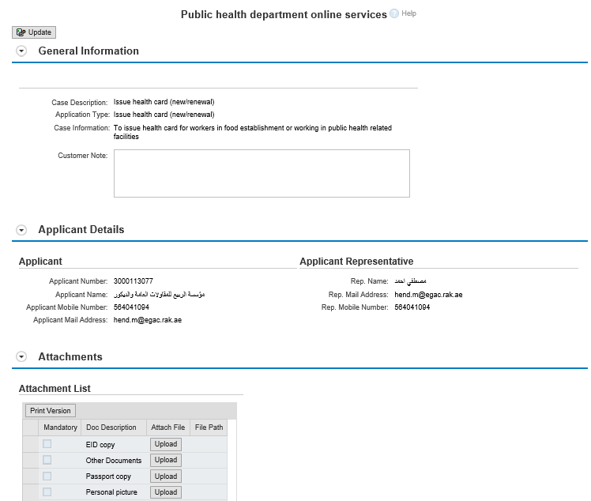
- Modify the request as per the PHD employee comments through add/replace or delete the request attachments.
- Click the “Update” button. A confirmation message will pop up:
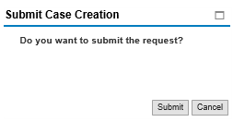
- Click “Submit”, then you will return to the “Customer Action” screen:
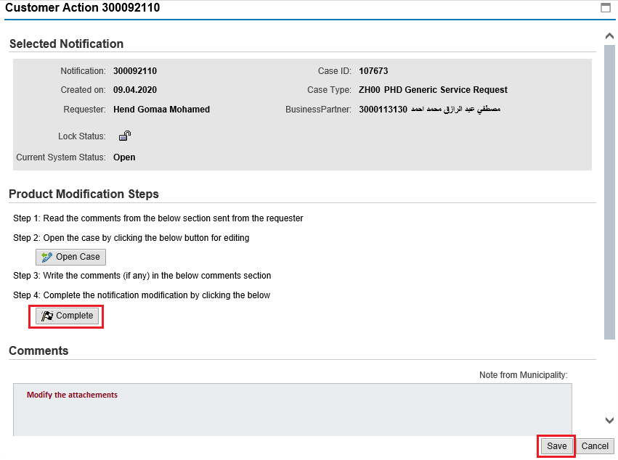
- Click “Complete” and then “Save” to complete your modifications the request will be removed from “My Notifications” tab and the request will be submitted again to the PHD employee for review and take the decision.

After getting your request approved by the PHD employee, you will receive the required result such as certificate, online. The PHD employee will send you a soft copy of the required certificate on your Email through the system.

Appendix i
Establishment update information form
PHD online services prices

