User Manual
Register Workers under Public Health Related Facilities
Public Health Department

Contents:

- Introduction: 3
- Create a New Workers Registration Request 8
- Create a Workers Registration Request from Draft 19
- My Cases 22
- Service Fee 28
- Customer Action 29

Introduction:

The Public Health Department (PHD) of Ras Al Khaimah has published various online service to save the customers time and efforts, and to enable them to submit any request anytime from anywhere.

The customer (individuals /establishments) should have a registered account on the Public Health Department to be able to use the online services.

This service allows the establishments’ representatives to register the establishment’s workers including themselves by providing the required documents in order for them to issue the health certificate once required later.

This guide shows establishments’ representatives how to access the Register Workers under Public Health Related Facilities service. It also guides them on how to create, send and track the request electronically.
Representatives will be able to log in to the service, submit requests, track requests, modify requests (if necessary), re-submit the requests after applying the modifications electronically, and finally receive the registration confirmation short messages SMS on their mobile phone.

Important Notes:
- To be able to apply for online services, the customer must apply on the Business Partner Establishment Update Information service, register his establishment and update his information in the system.
- The registration process is carried out electronically on the Ras Al Khaimah government link by following the steps below until reaching the services of Ras Al Khaimah Municipality →Public Health Department → Public Health Department Online Services, by submitting the following documents to register/update the establishment:
  - Copy of the License
  - Lease Contract/ Title Deed
  - Filled Establishment update information form for (Owner / manager / Representative contacts, EID number)
  - Letter of Authorization from the Company (if registering a company representative) with the ID/ Passport Number, full name and representative’s relation to the Company
N.B. In case Manager / owner is not mentioned in license
- The Customer must also register a company representative (an individual) by providing the following documents:
- Create an Internet user (Electronic Company Representative) and RAK Government portal account by:
    - Registering in RAK Government portal.
    - A valid Emirates ID Card is needed for the request
- Provide a letter of authorization from the Company including the company representative’s name, ID/Passport number and contact information
- Provide the representative’s ID/Passport number

Login and access to the Register Workers under Public Health Related Facilities Service
- Navigate to the RAK Government portal on https://www.rak.ae/wps/portal
- To access the Register Workers under Public Health Related Facilities service, click on the “Service Guide” then click on “Government”
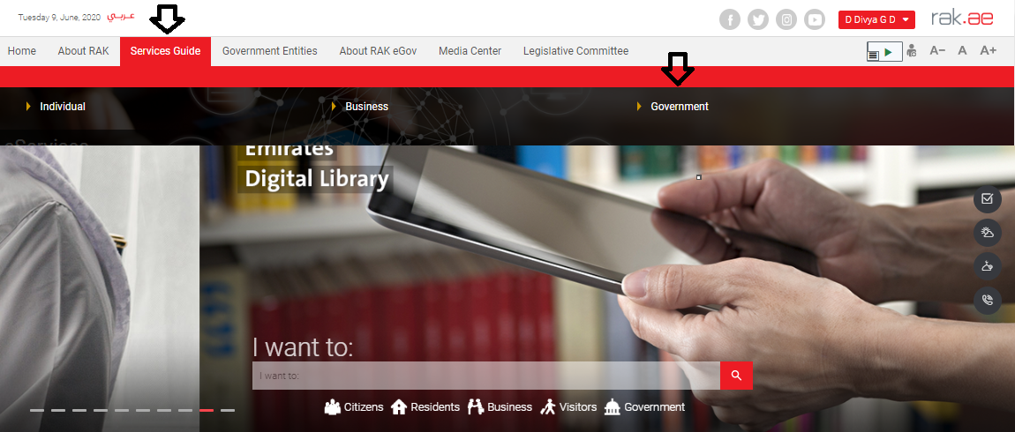

- Next, select “RAK Municipality”
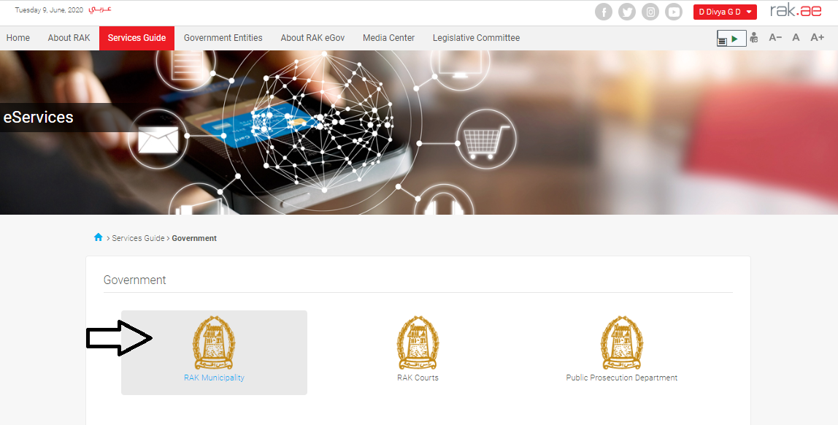
- Next, select “Public Health Department”

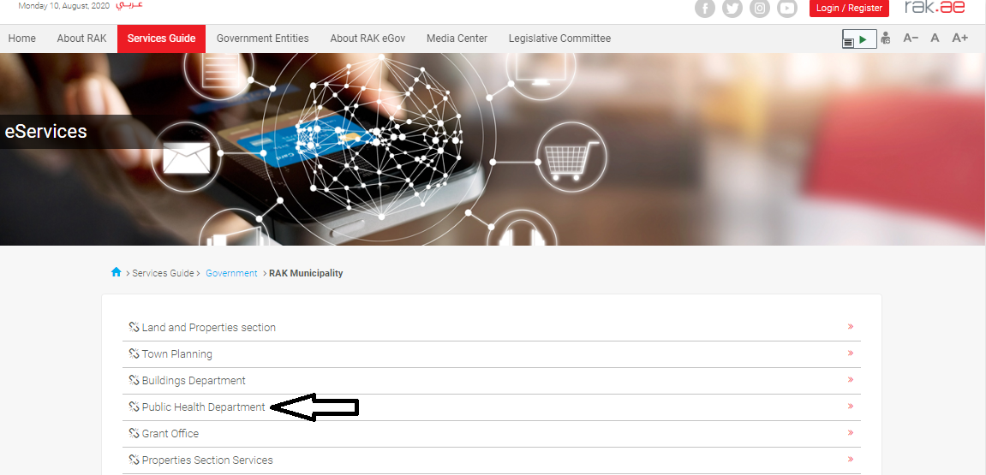

- Next, click on the Worker Register

- The service screen displays the service definition, procedure, conditions, fee, time, and the required documents.

- To use the service, click on the “Start Service” button.

Create a New Workers Registration Request

- After you access the Register Workers under Public Health Related Facilities and click on the “Start Service” button, the login page will appear as follow:
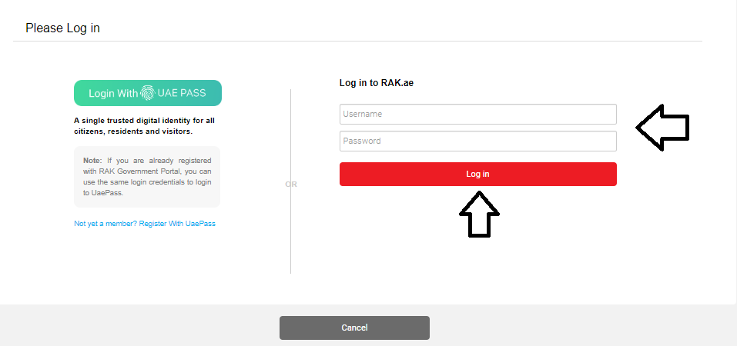
- Enter your RAK Government Portal username and password which you have previously created, then press on the “Log in” button.

- The Company Information form will be displayed enabling you to select the required establishment for which you want to register workers:
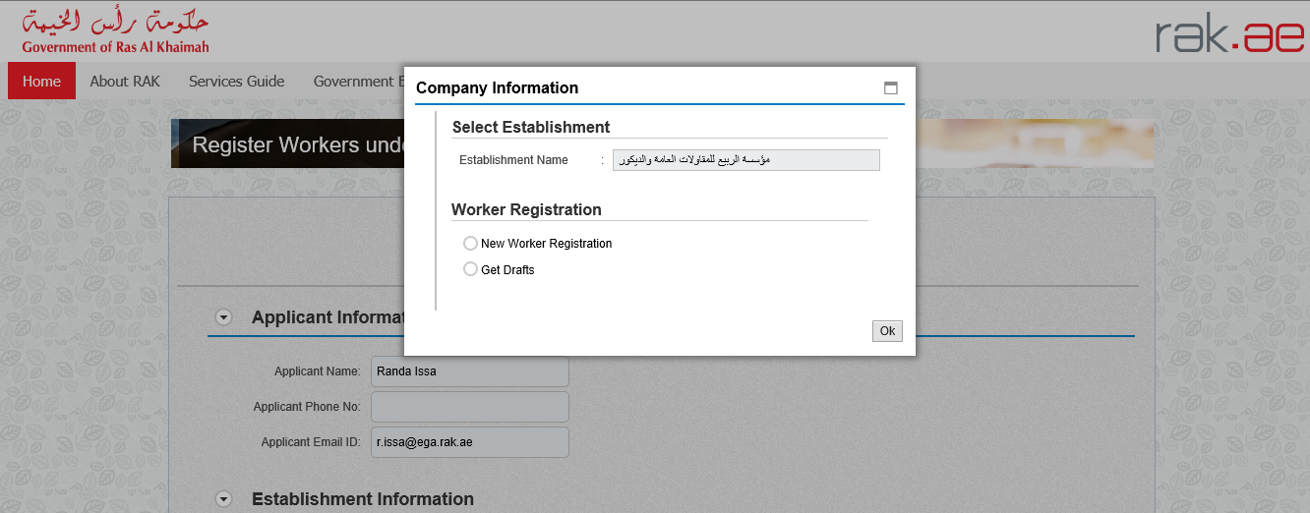

Notes:
- If the establishment license is expired, you will not be able to submit the request.
- You will not be able to register a worker in more than one establishment.

- Select the establishment for which you want to add works from the Establishment Name dropdown list.
- To create a new request, select the “New Worker Registration” option then click “Ok”:
Then the Register Workers under Public Health Related Facilities request form will be displayed enabling you to create the new request:

- View and check your information in the “Applicant Information” block:
- View and check the information of your establishment in the “Establishment Information” block:

Note: to view the establishment’s activities, click on the “Show” button beside the “License Activity” item, then the activities list will pop up as below:
Click the “Close” button to close the screen.

- Add the workers who you want to register in the “Employee Details” block one by one as below:

  - Click on the “Add Row” button to have a new row displayed below enabling you to enter the employee information and attachments:
  - Select the employee profession from the “Profession” dropdown list:
  - Click on the “Search BP” button to search for the employee:
The search form will pop up allowing you to search for the employee and add it:
  - Select the appropriate way of search from the dropdown menu of “Selection Criteria”, then enter the required inputs as follows:
The dropdown menu includes many search options and upon your selection, the required inputs will be changed as follows:

Required inputs | Search way
Search by the Emirates ID, then enter:
- EID number
- Select the nationality
- Select the date of birth
Search by the passport number (for non-Emirates ID holders), then enter:
- Passport number
- Select the Passport type
- Select the nationality
- Select the date of birth
Search by the unified ID (for non-Emirates ID holders) then enter:
- Unified number
- Select the nationality
- Select the date of birth
 | Myself: if you are the worker who you want to register, select this option.

  - Enter the code that appears in the figure, then click on “Search” button below the figure.

Note: enter “Refresh” button to get a new clearer code, or click on “Clear” button to clear the input and re-write the code again.

The search result will show the employee name as below:
  - Click “Ok” to have it displayed in the form as below:

- Attach all of the mandatory documents (visa copy, passport copy, personal picture) and the optional Emirates ID (if available) to complete the request. You also, can edit all attachments (add new or remove/replace existing).
  - To upload documents, Click the “Browse” button under the required document caption, a window pops up allowing you to choose the files as below:
  - Browse for the file and Click on Add the file will be uploaded successfully.
  - Repeat the steps to attach next documents.

Notes:
- Once the document is attached successfully, a green tick will appear on its caption.
- To view or delete the attachments, click on the “Show” button to the right of the employee record. Then, the following form will pop up:
- Click on the View Icon to view the document.
- Click on the Delete icon to delete the document.
- You will not be able to register a worker whose visa or passport is expired.

- Delete an employee by selecting the required employee, then clicking on the “Delete Row” button:
- Enter you notes in the “Remarks” field:
- After filling the mandatory fields, you have options to:

- “Save as Draft” to keep the request in your draft for later submission.
- “Back to Initial Screen” to start over a new request.
- “Submit” to complete the request and submit it.
- Click “Submit” and confirm the submission in the displayed confirmation message.
A screen will appear stating that the case is submitted in addition to the case ID.

Notes:
- You can add up to 20 workers in one request.
- Upon submission, the system will show error messages at the top of the request if there any problem related to any of the entered workers as below:
- Upon successful submission, an Email and a short message SMS will be sent to the applicant stating that the worker registration request is submitted successfully.

After the request is submitted, you need to access your cases on the RAK Portal www.rak.ae to track your request.

When you submit the Register Workers under Public Health Related Facilities, it is received by the PHD Customer happiness employee to review it and accordingly the employee will do one of the following actions:
- Accept the request, after which you will receive a confirmation message SMS for the same.
- Reject the request stating the justifications, after which you will receive an email and a short message SMS for the same.
- Return the request for modification after which you will receive an email and a short message SMS for the same. In addition, you should modify the request as per the notes then re-send it to the employee to review it again and take the appropriate action against it.

Note: To get your feedback regarding the service procedure, the following happiness meter screen will pop up along with the request result screen allowing you to submit how happy you were for the same:
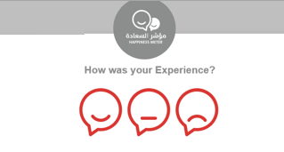
Select the required face and your evaluation will be submitted directly.

Create a Workers Registration Request from Draft
If you have created a workers’ registration request before and saved it as a draft, you can open it and submit it any time instead if create it again as below:

- After you access the Register Workers under Public Health Related Facilities and click on the “Start Service” button, the login page will appear as follow:
- Enter your RAK Government Portal username and password which you have previously created, then press on the “Log in” button.

- The Company Information form will be displayed:

- Select the establishment for which you want to add works from the Establishment Name dropdown list.
- Select “Get Draft” option and click “OK”:
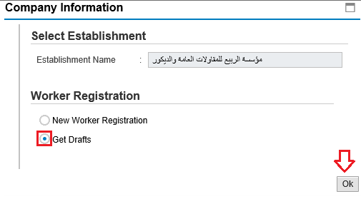
Then, the List Draft cases will be displayed as below:

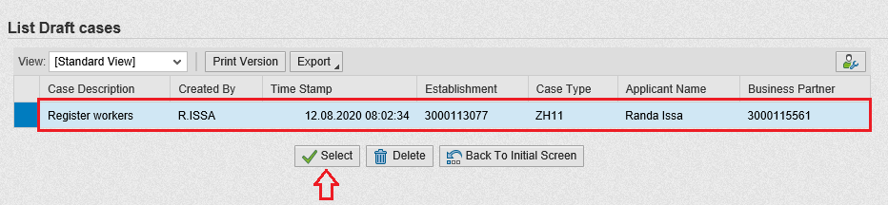

- Select the required draft and click on the “Select” button to open it and complete with the request update and submission as explained before.
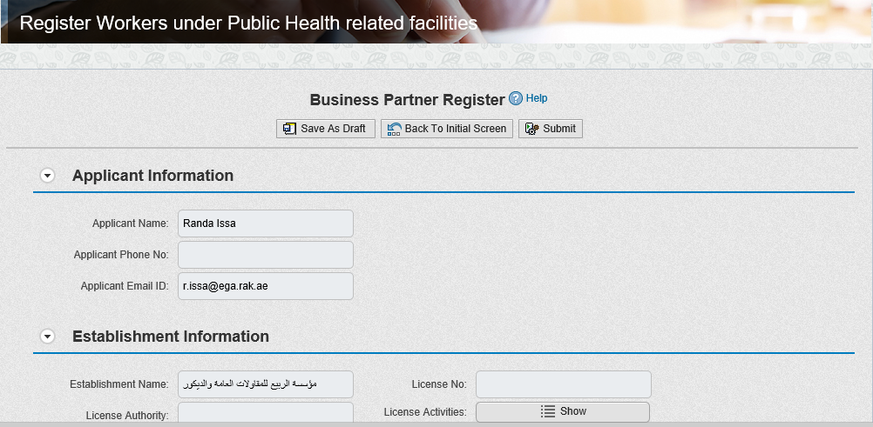
- To delete a request draft, select the required draft and click on the “Delete” button:
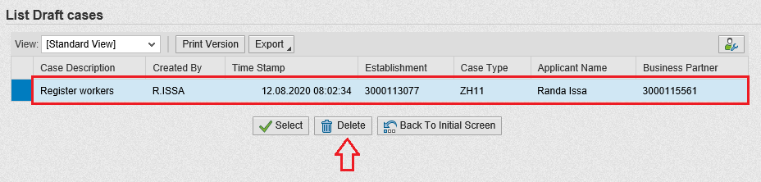

My Cases

You can find the submitted requests under “My Cases” tab on the RAK Government portal https://www.rak.ae/wps/portal

To access the My Cases page, click on the “Service Guide” then click on “Government” item.

Next, select “RAK Municipality”

Next, Select the “Public Health Department”

Next, Select “My Cases”
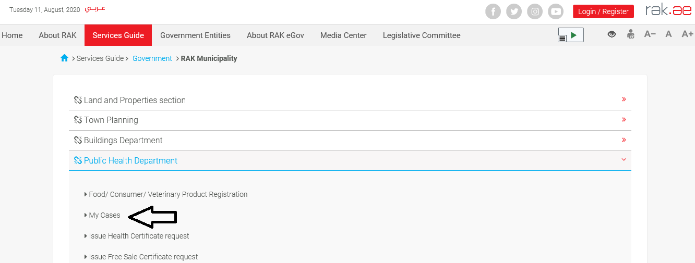

Next, enter your RAK Government Portal username and password which you have previously created, then press on the “Log in” button.

“My Cases” tab will be displayed to show all of your transactions submitted to the Public Health Department and pending for PHD approval.

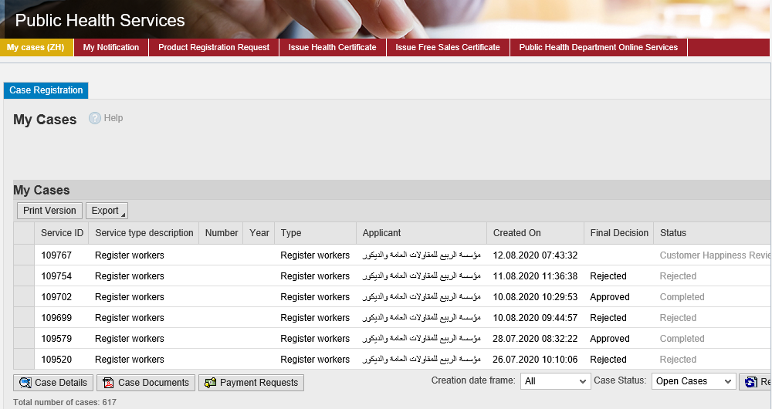
“My Cases” Tab displays the service ID, description, type, applicant, creation date, final decision and the status for each request.

Note: you can do the following for each case/ request created:
- Print (As a Pdf)
- Export (As excel files)
When selecting the request, and perform any of Print version or export, the system will automatically generate / download the required case

- You will be able to view the details of the service request by selecting the required request and then clicking on the “Case Details” button
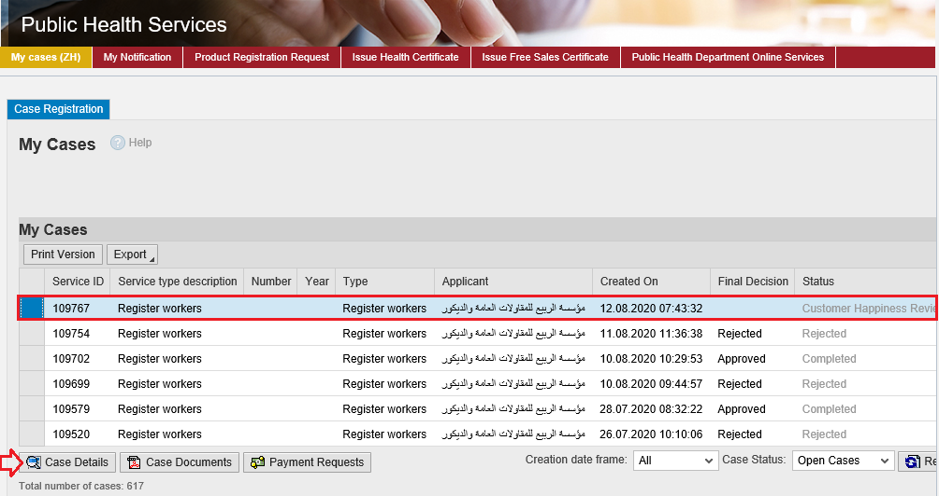

The details screen of the selected request pops up to show all of its details as below:

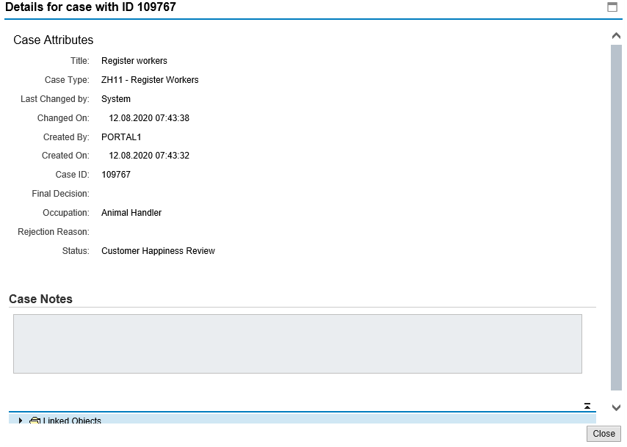

- You will be able to view the attachments of the service request by selecting the required request and then clicking on the “Case Documents” button

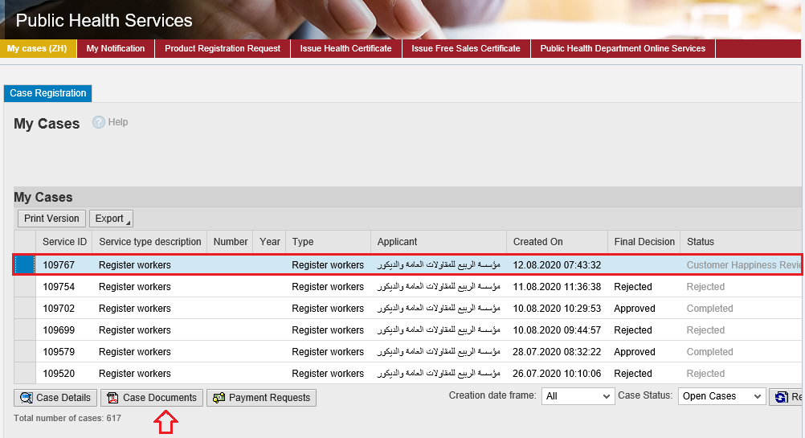

A screen will pop up to show all of the documents that are attached to the selected request when it is created.

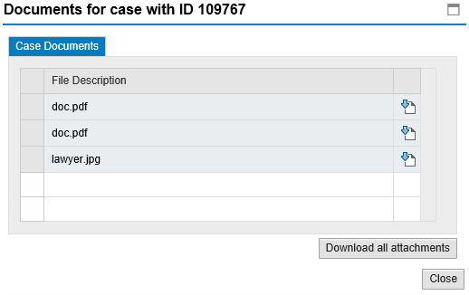
Click the Download icon beside the required document to download it, or click on the “Download all Attachments” button to download all of the attachments at once.

Service Fee
The Register Workers under Public health related Facilities service is provided free of charge.

Customer Action
Upon successful submission the request will be displayed for the PHD customer happiness employee to review it and take the decision, but if the request requires a modification from the applicant, then the employee will return it to the applicant to apply the modification and send it again after modification for review.
When your request is returned to you for modification, you will find it in “My Notification” tab. To access “My Notification” tab, follow the same procedure you did to reach “My Cases” Tab.
In “My Notification” tab, you can open the request for modification as in the screen below:
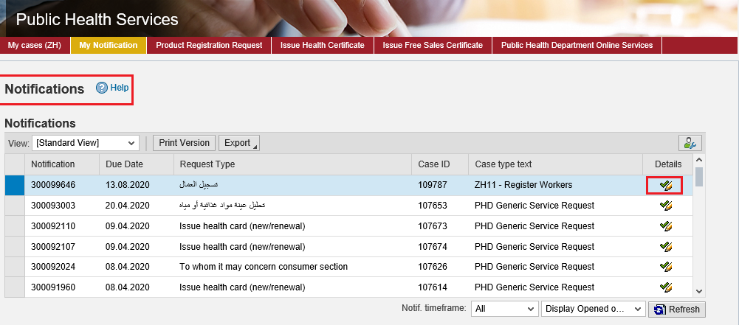
To modify a request, follow the step below:
- Click the “Details” icon to the right of the required request the “Customer Action” screen pops up as below:
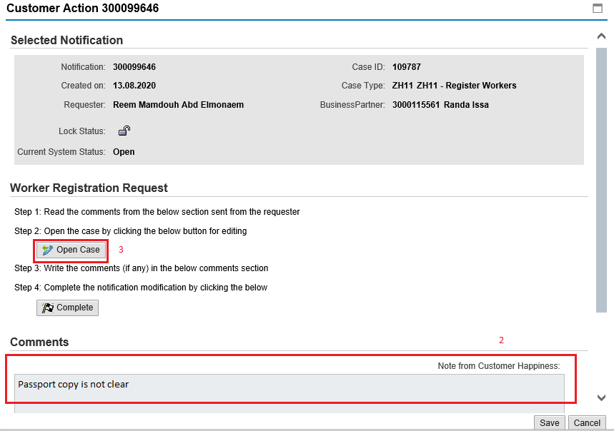
- Read the notes of the PHD customer happiness employee.
- Click on “Open Case” button to modify the request the request details screen opens
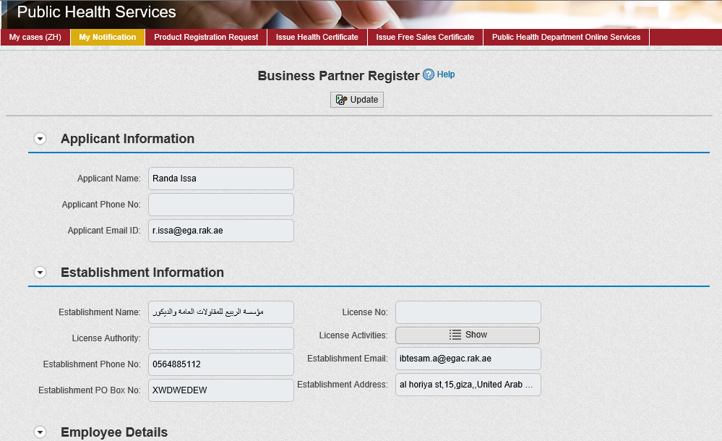
- Modify the request as per the employee comments through add/replace or delete the request attachments. In addition, you can add remarks.
- Click the “Update” button. A confirmation message will pop up:
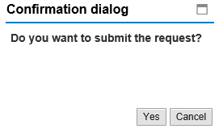
- Click “Yes”, then you will return to the “Customer Action” screen:
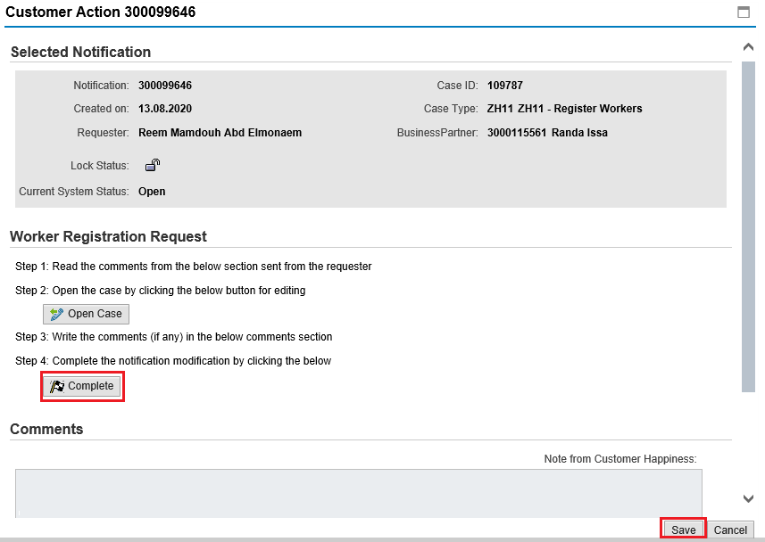
- Click “Complete” and then “Save” to complete your modifications the request will be removed from “My Notifications” tab and the request will be submitted again to the PHD employee for review and take the decision.

After getting your request approved by the customer happiness employee, you will receive a confirmation short message SMS on your mobile phone stating that the worker is registered successfully.

Note that a message will be sent for each registered worker even if they are in the same registration request (a confirmation message per single worker)

