User Manual
Appeal Against Violation
V1.0
General Services

Contents:

- Introduction: 3
- Create an Appeal Against Violation Request 8
- My Cases 14
- Fee Payment 19

Introduction:

The Ras Al Khaimah Municipality launched a set of electronic services to save customers time and effort and enable them to submit their requests at any time and from anywhere.

This service will allow the establishments’ representatives to submit an appeal against unpaid violation(s) after attaching the required documents.

This guide shows customers how to access the Appeal Against Violation request. It also guides them on how to create, send and track the requests electronically.

Customers will be able to log in to the electronic services of the section, submit requests, track requests, and finally get them approved or rejected electronically.

Login and access to the Appeal Against Violation Service

- Navigate to the RAK Government portal on https://www.rak.ae/wps/portal
- To access the Appeal Against Violation request, click on the “Service Guide” then click on “Government”
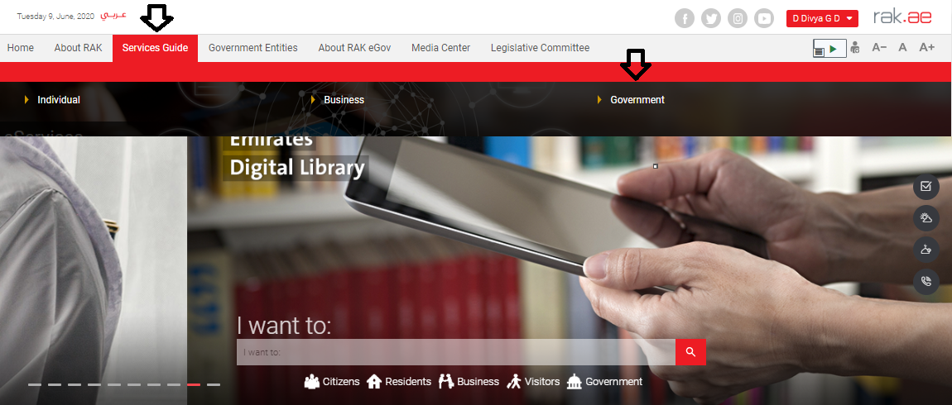

- Next, select “RAK Municipality”

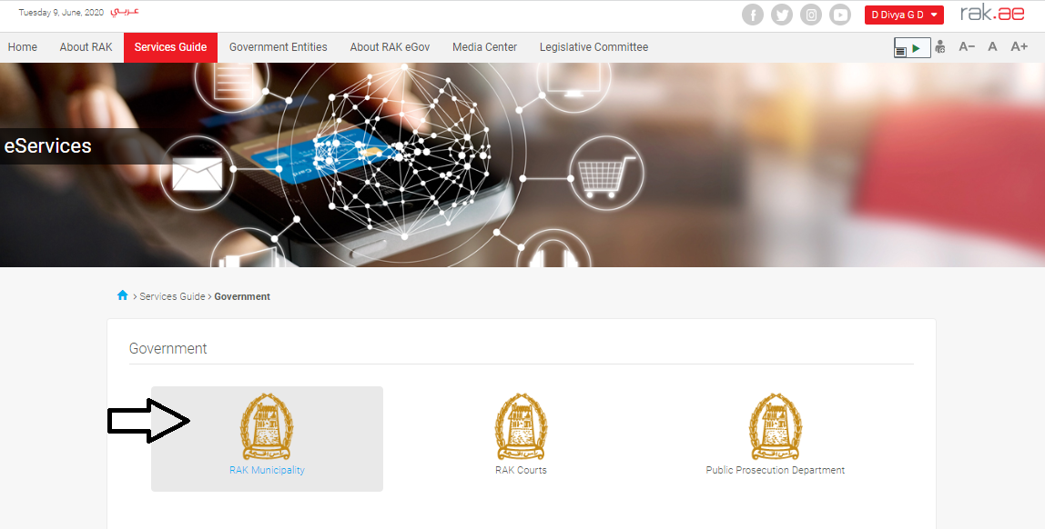

- Next, select “General Service”

- Next, click on the Appeal Against Violation

- The service screen displays the service definition, procedure, conditions, fees, time, and the required documents.

- To use the service, click on the “Start Service” button.

Important Notes:
- To be able to apply for online services, the customer must apply on the Business Partner Establishment Update Information service, register his establishment and update his information in the system.
- The registration process is carried out electronically on the Ras Al Khaimah government link by following the previous steps until reaching the services of Ras Al Khaimah Municipality → General Services →Business Partner Establishment Update Information for companies, by submitting the following documents to register the establishment:
  - Valid registration certificate.
  - A copy of the trade name certificate or trade license.
  - Fill out the company information document and the licensee / managers / company representatives
  - The EID of the company owner and manager

- The Customer must also register a company representative (an individual) by providing the following documents:
- Create an Internet user (Electronic Company Representative) and UAE Pass account, a valid Emirates ID Card is needed for the request
- Provide a letter of authorization from the Company including the company representative’s name, ID/Passport number and contact information
- Provide the representative’s ID/Passport number

Create an Appeal Against Violation Request

- After you access the Appeal Against Violation Request and click on the “Start Service” button, the login page will appear as follow:

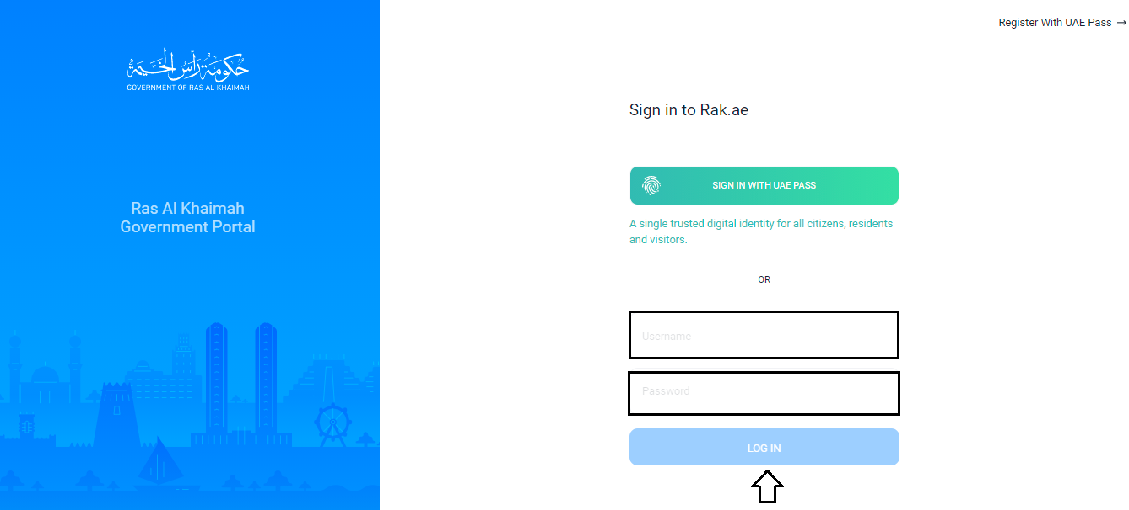

- Enter your RAK Government Portal username and password which you have previously created, then press on the “Log in” button.

- The Appeal Against Violation request form will be displayed enabling you to submit it:

- In the General Information block, enter the description of your request in the “Title” field.

- Select the establishment for which you want to submit the appeal request against its’ violations from the dropdown list of the “Applicant” field, then the information of the selected establishment will be displayed below:

Note: The “Applicant” dropdown list displays the establishments to which the applicant is registered within the electronic services of the Ras Al Khaimah government as a representative.

- You can select the violation against which you want to submit the appeal request, from the Appeal Against Violation Details block by two ways:
  - Enter the case number of the required violation case and press the "Enter" key, to have the related list of violations being displayed below, then select the required violation(s):

  - Or, click on the Search icon in the "Related Violation Case" field, to have the list of the related violation cases being displayed as follows:

Select the required case to have the related violations displayed in the violations list enabling you to select the required violation(s) for which you want to appeal against:

- Enter the description of the selected violations in the “Appeal Description” field:

- In the Attachments block you have to attached all of the documents (Violation report and violation clarifications in addition to any image or video that may support your appeal) to complete the request. You also, can edit all attachments (add new or remove/replace existing).
- To upload documents:
- Click the “Add Attachment” button, a window pops up allowing you to choose the files as shown below:

- Select the name of the document to be attached from the “Document Type” drop down list:
- Browse for the file and Click on Add the file will be uploaded successfully.

- Repeat the steps to attach next documents.
Notes:
- Click “Scan Attachment” to upload the document directly from the scanner.
- In case of incorrect upload, you can select the record and click the “Delete Attachment” button to remove it

- After you fill the request mandatory fields, you have options to:

- “Initiate Service” to complete the request.
- or clear all fields by selecting “Clear”

- Click “Initiate Service” and confirm the submission in the displayed confirmation message.

A message will appear stating that the case is submitted in addition to the case ID.

After the request is submitted, you need to access your cases on the RAK Portal www.rak.ae to track your request and upon approval, the violation will be cancelled.

Note: To get your feedback regarding the service procedure, the following happiness meter screen will pop up along with the request result screen allowing you to submit how happy you were for the same:
Select the required face and your evaluation will be submitted directly.

My Cases

When you submit one of the Appeal Against Violation request, it is received by the head of the concerned section in the municipality to review it and accordingly he/she will take one of the following decision:
- Accept the request, then the violation will be cancelled.
- Reject the request stating the justifications, then you have to pay the violation fee.
- Ask for a new violation report by a new inspector than the one who did the first report, and upon the new report the section head will take the right decision.

Note: when the concerned section head takes one of the above mentioned actions, the system will notify the customers by sending SMS on their mobile phones and Emails to let them know if their request is accepted, rejected or needs new violation report.

You can find the submitted requests in “My Cases” tab, to access it please visit the Ras Al Khaimah Government website at www.rak.ae as shown on the screen below.

Then, Click the “Service Guide” then click “Government”:

Next, select “RAK Municipality”

Next, Select the “Buildings Section”

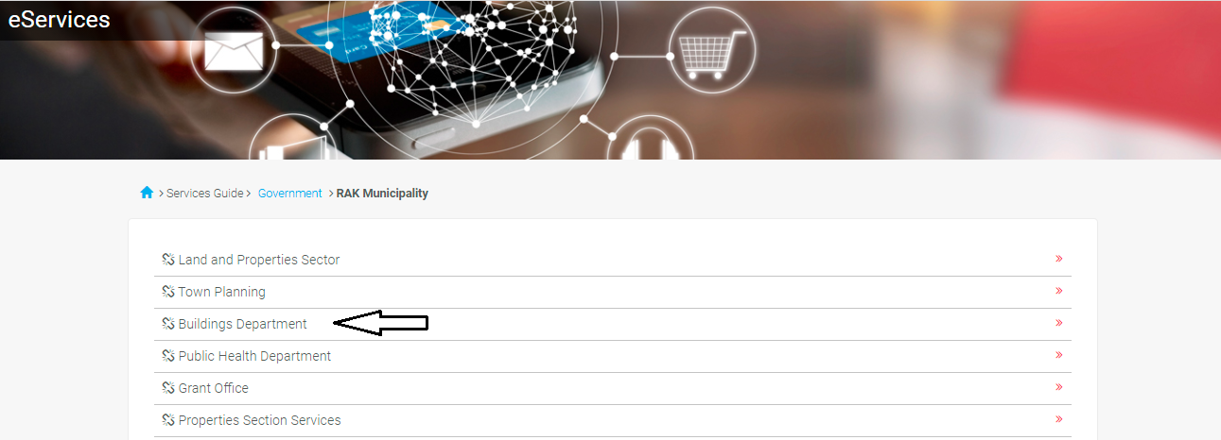

Next, Select “General Services”

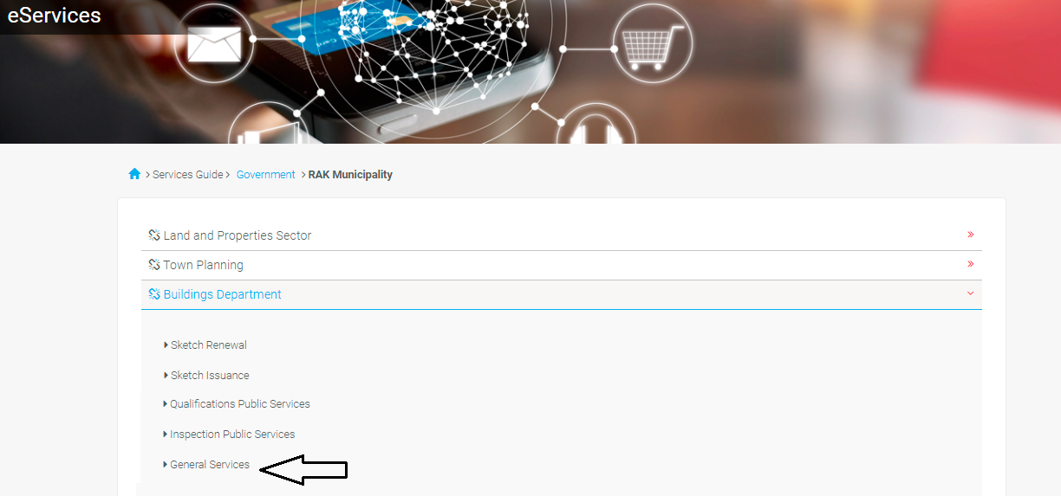

Next, Enter your RAK Government Portal username and password which you have previously created, then press on the “Log in” button.

“My Cases” tab will display all of your transactions that are submitted to the Buildings section.

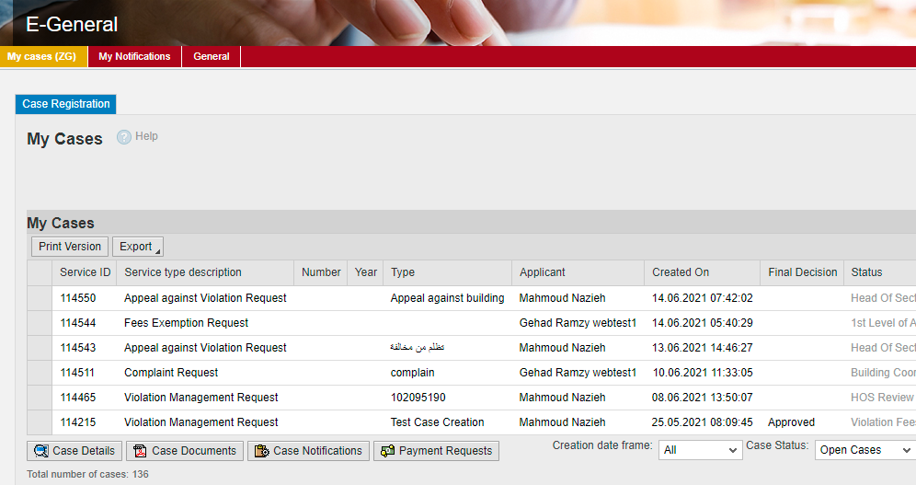

“My Cases” Tab displays the service ID, description, type, applicant, creation date, final decision and the status for each request.

Note: you can do the following for each case/ request created:
- Print (As a Pdf)
- Export (As excel files)
When selecting the request, and perform any of Print version or export, the system will automatically generate / download the required case

- You will be able to view the details of the service request by selecting the required request and then clicking on the “Case Details” button:

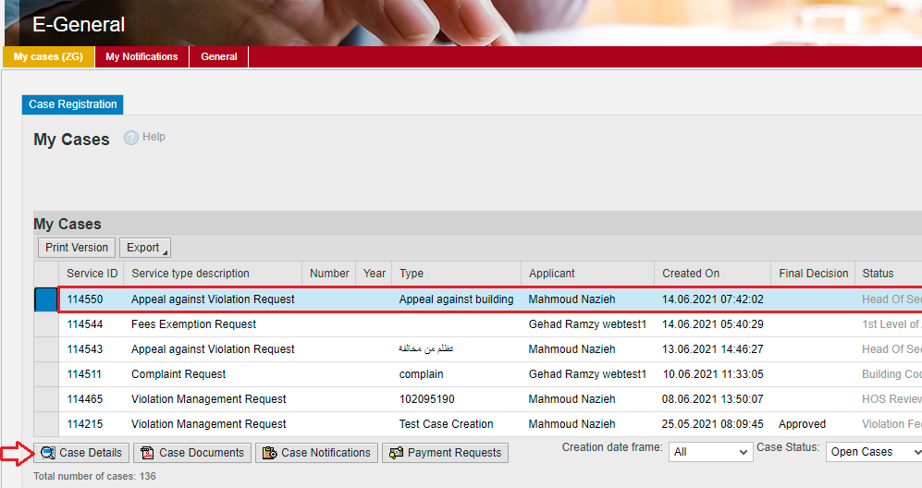

The details screen of the selected request pops up to show all of its details as below:

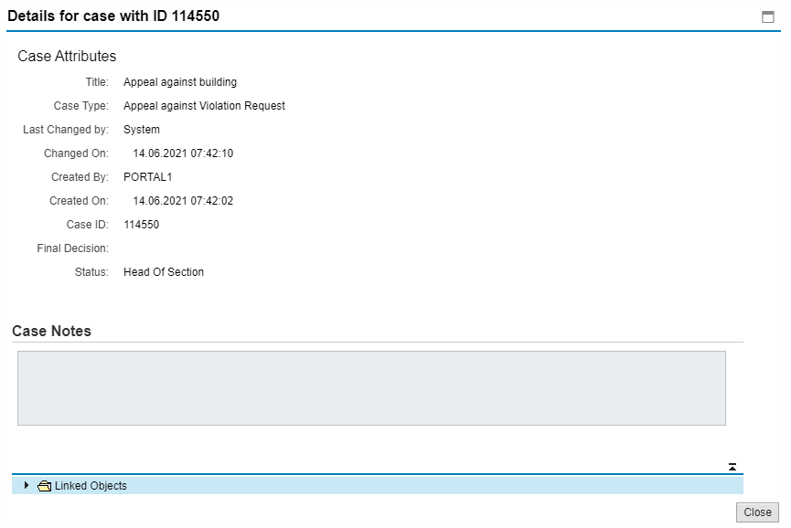
- You will be able to view the attachments of the service request by selecting the required request and then clicking on the “Case Documents” button
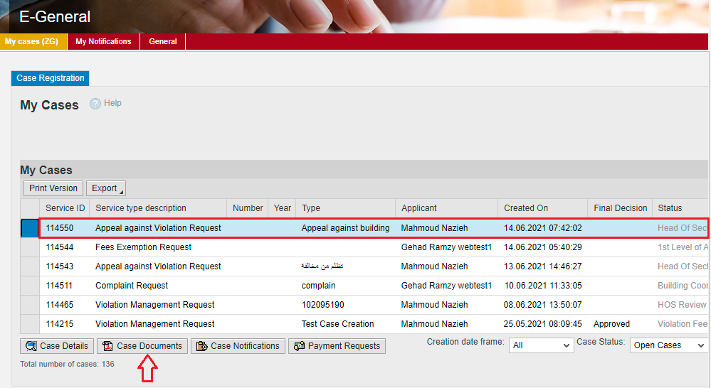

A screen will pop up to show all of the documents that are attached to the selected request when it is created where you can upload any file or all of the files.

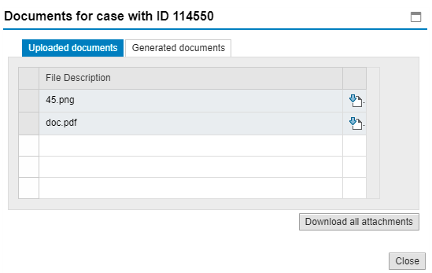

Fee Payment
The service of free of carge

